**What is new HealthPro Bridge v1.8**

**NEW FUNCTIONALITY, DEVICE COMPATIBILITY AND INTEGRATIONS**

* A browser UI replaces the thick client application to simplify the remote configuration of a HealthPro Bridge server as long as there is network access and/or local port forwarding. This will reduce the dependence on desktop-sharing tools such as Remote Desktop. E.g. <https://[ip_address]:3002>

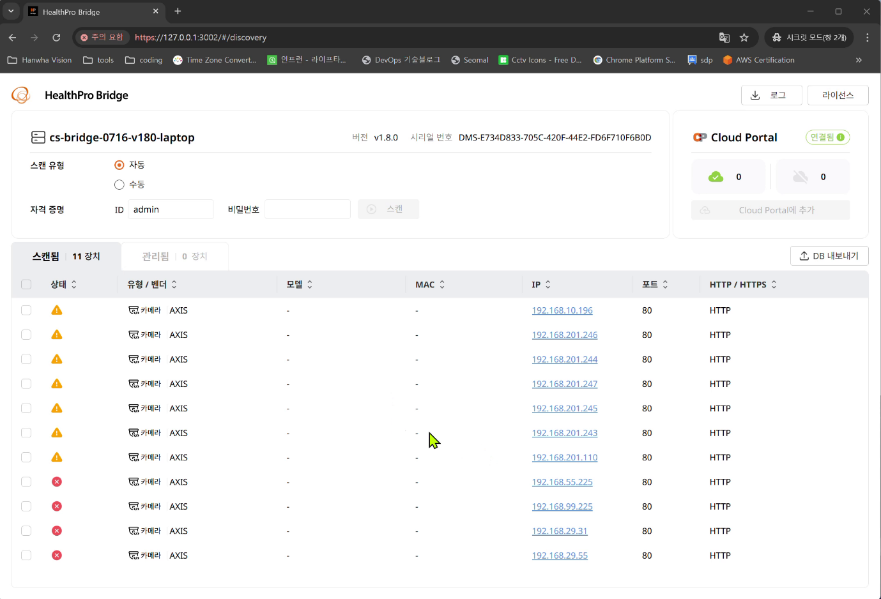

* Linux support. HealthPro Bridge now runs natively on Ubuntu 22.04 in addition to Windows.

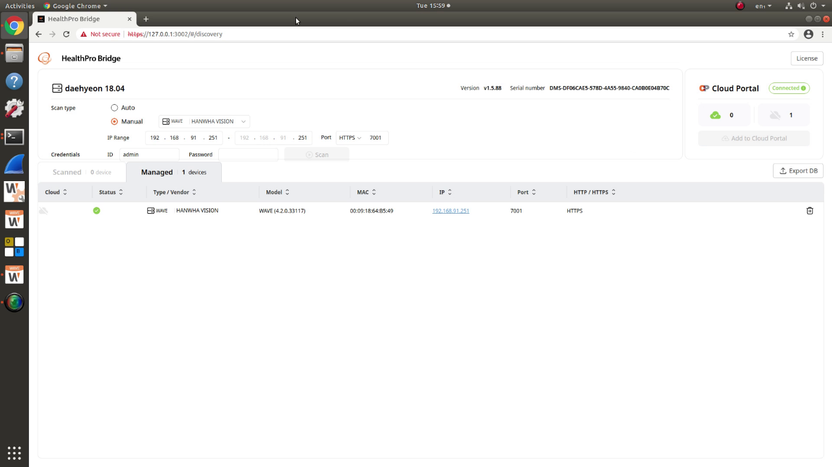

* Linux CLI. A command line interface is available for configuring and using a Linux HealthPro Bridge, however the web GUI is the recommended method.

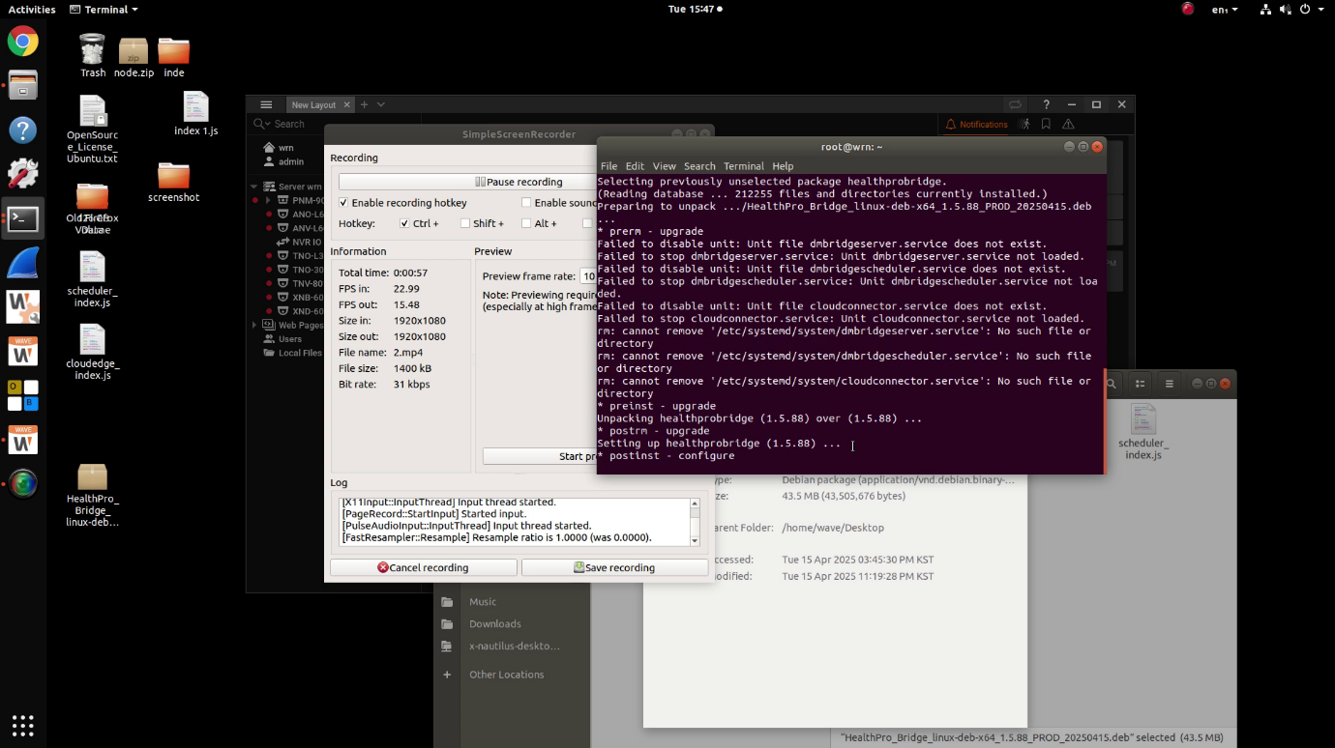

* Collect HealthPro Bridge log files to assist with technical support. This can be particularly helpful diagnosing why a bridge is not connecting to Cloud Portal, or certain services are not running.

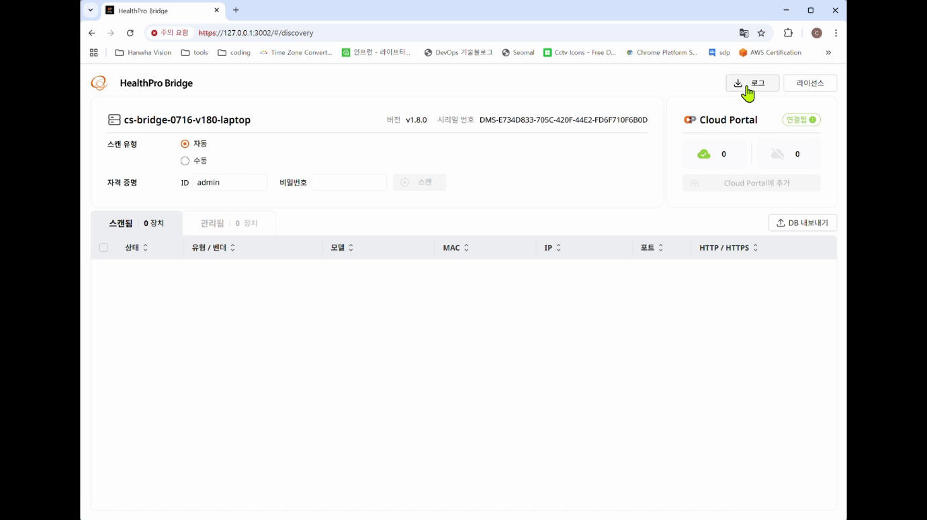

* Hanwha Vision PRN/XRN/QRN/ARN NVR support. The bridge must run on a separate machine and not on the NVR itself.

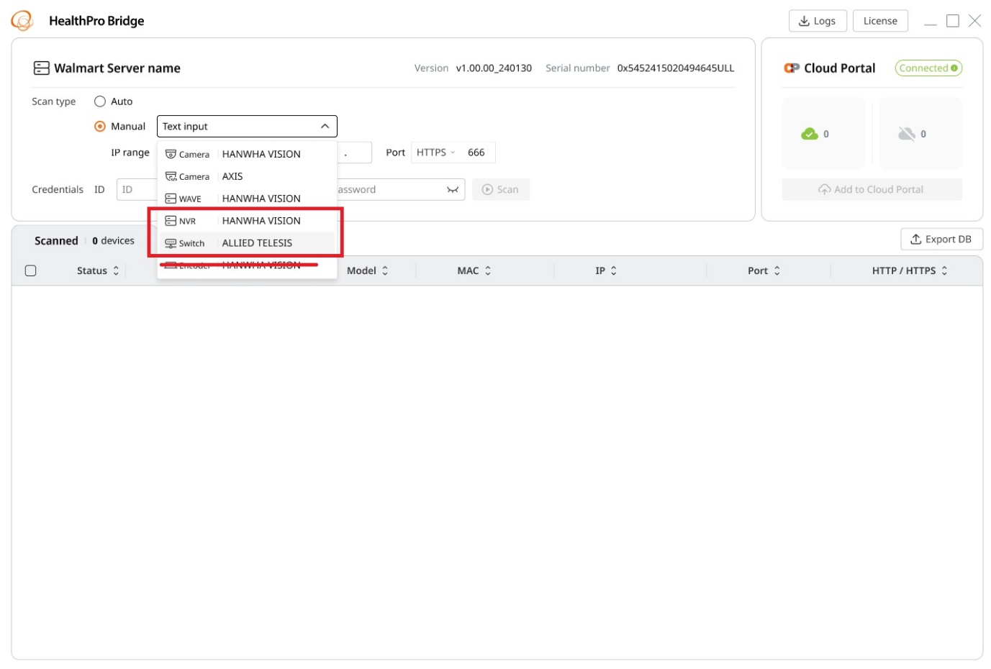

* Hanwha Vision (Allied Telesis) managed network switch support (running on a separate machine), to enable SNMP v2c. Note that HealthPro Bridge can only cycle the managed switch PoE port of a licensed HealthPro camera. It cannot cycle any other ports.

