**What is new HealthPro v1.8**

**General**

* Option to select dark mode for the entire GUI.

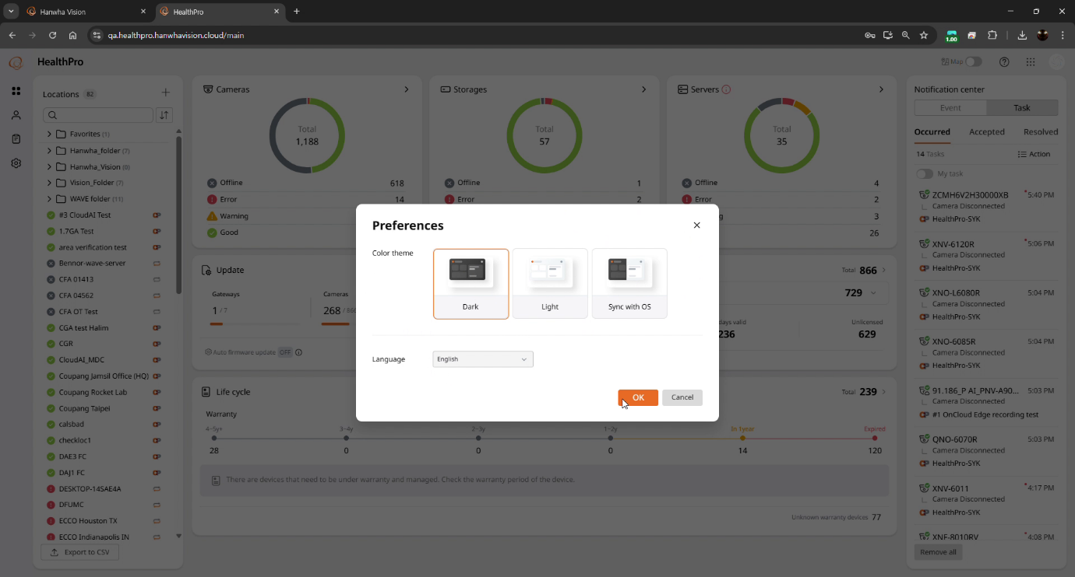

* Automatic enrollment. When a STEP Partner creates a new Customer Organization, all valid users of the STEP Partner Organization are automatically enrolled as HealthPro Managers within the Customer Organization so that they can immediately assist setup and configuration.

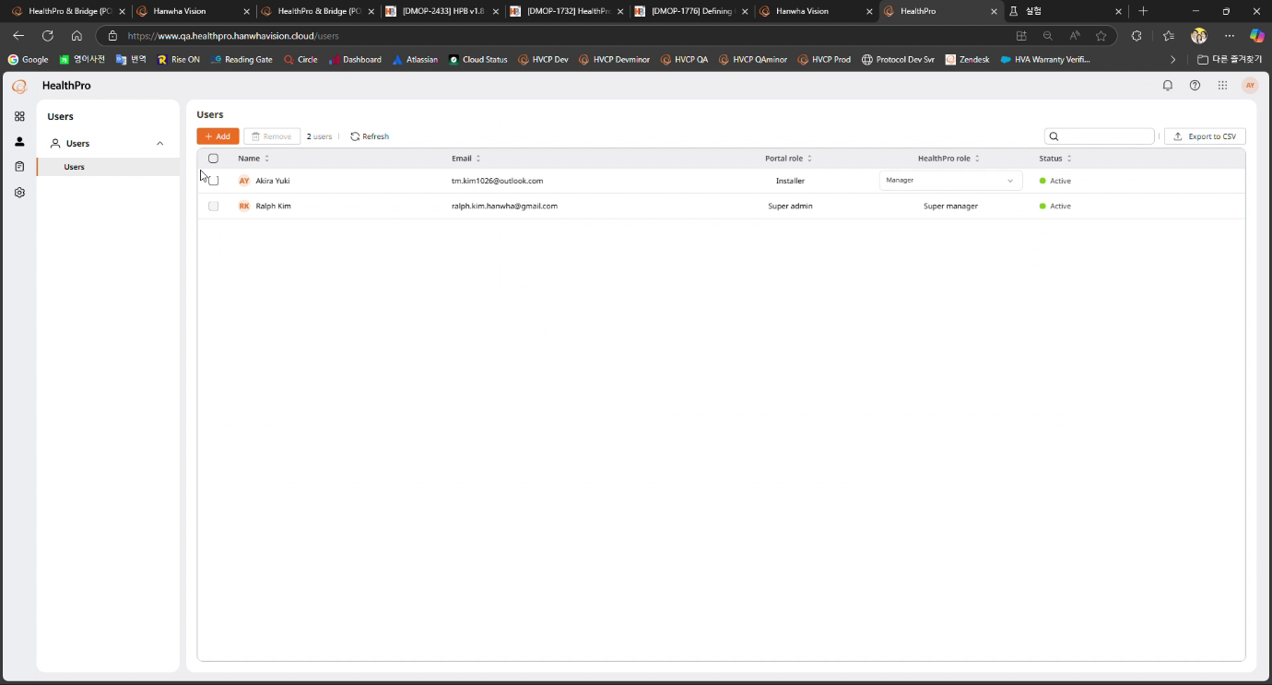

* Update or reconfirm warranty information using the Reconfirm feature in the Lifecycle dashboard.

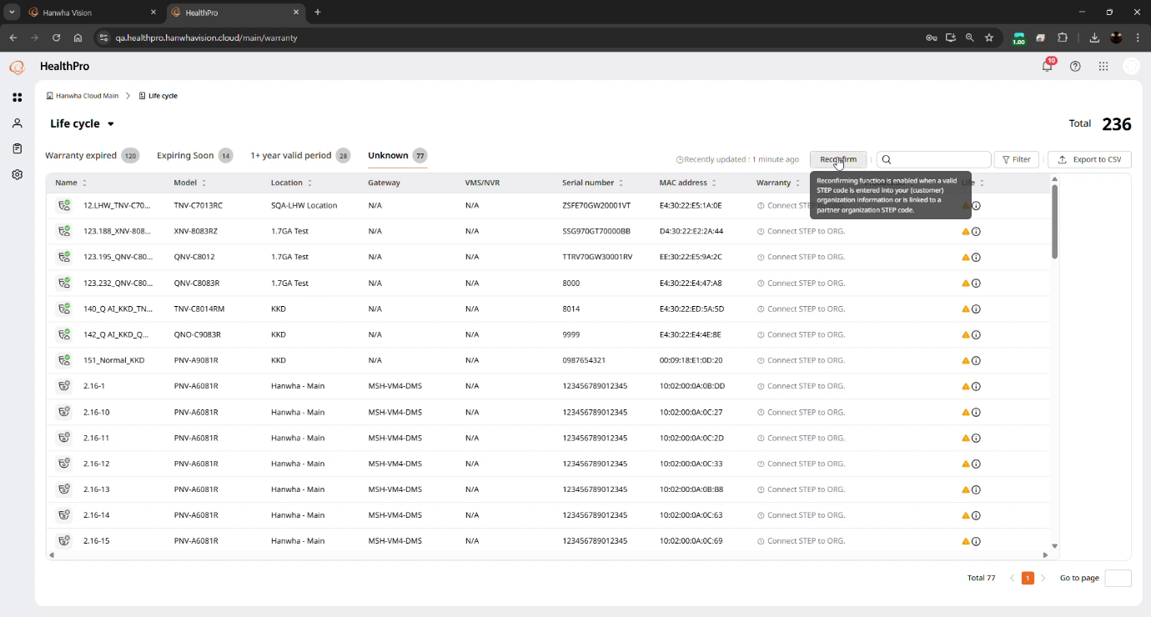

* Check that a Customer Organization is compatible with the versions of Health Bridge deployed.

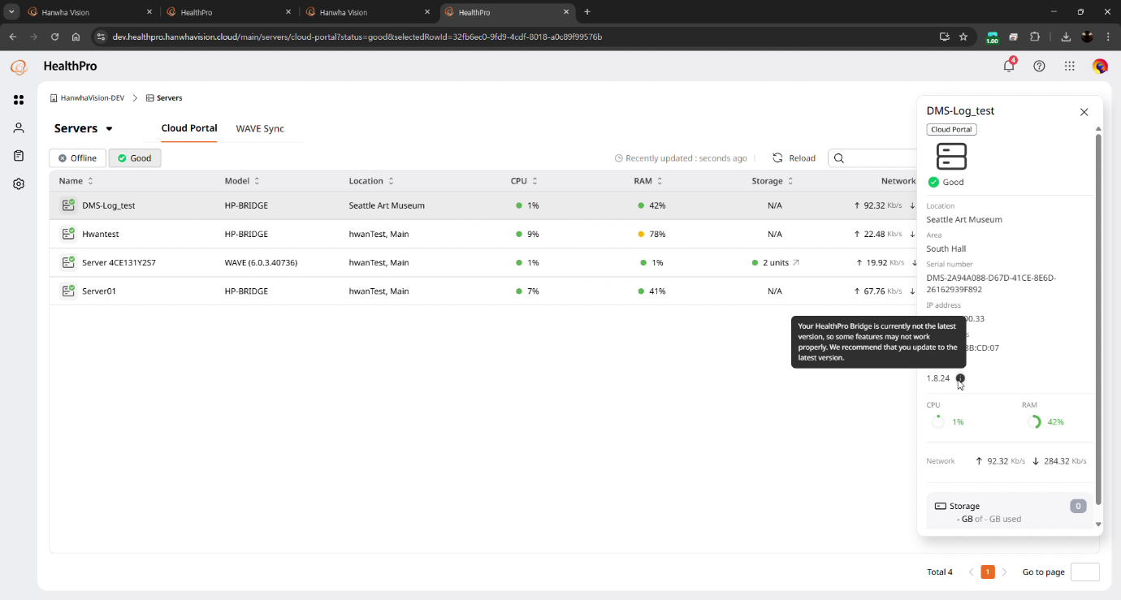

* As an assist to OnCloud, HealthPro indicates whether a given device is leveraging the SD card for local storage.

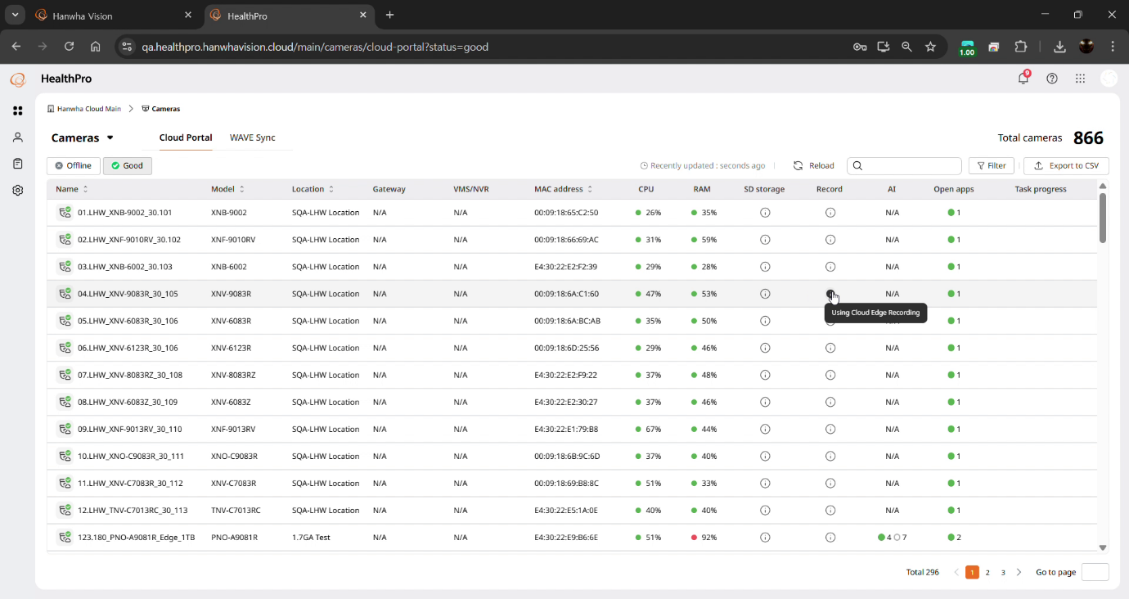

* View the list of accessible and licensed AXIS cameras, to assist with future planning.

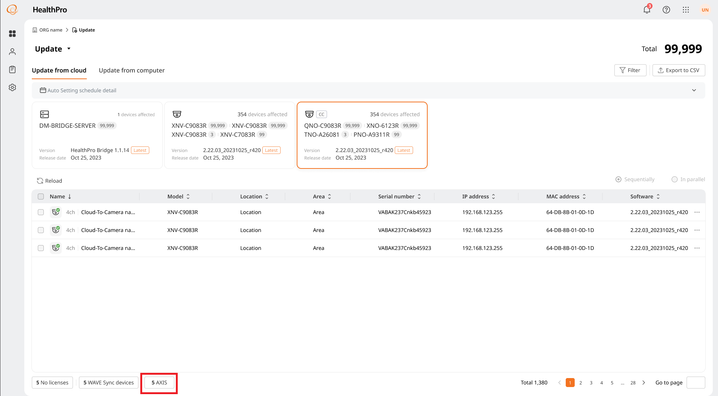

* Language support now includes English, French, German, Spanish, Portuguese, Italian, and Korean.

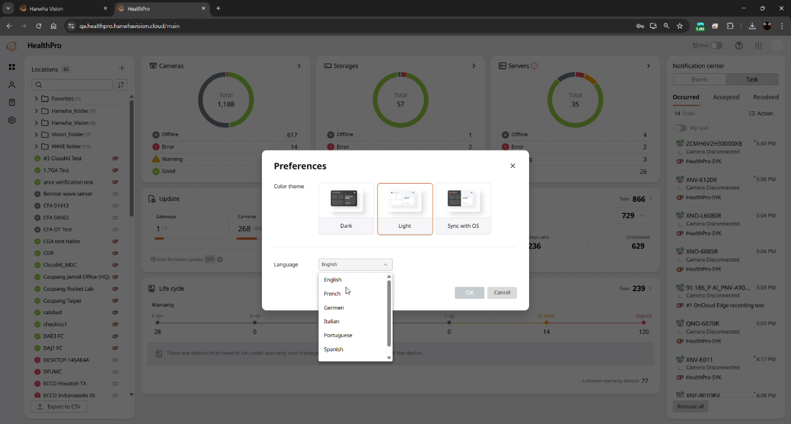

* Clicking on a status subgroup of servers or cameras, e.g. Good or Offline, opens the dashboard prefiltered for that group

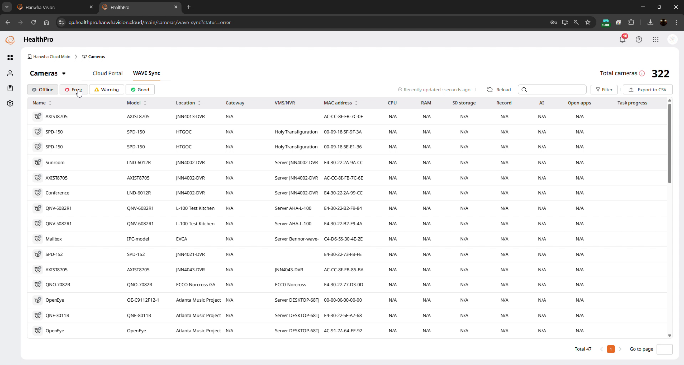

**Hanwha Vision Device Remote Configuration**

* Quick mode: Remotely enable, disable, or reconfigure specific camera settings, including WiseStream AI, WiseStream, full window motion detection, full window object detection, Bestshot, execute an autofocus, and change the device’s password. This mode also supports AXIS cameras.

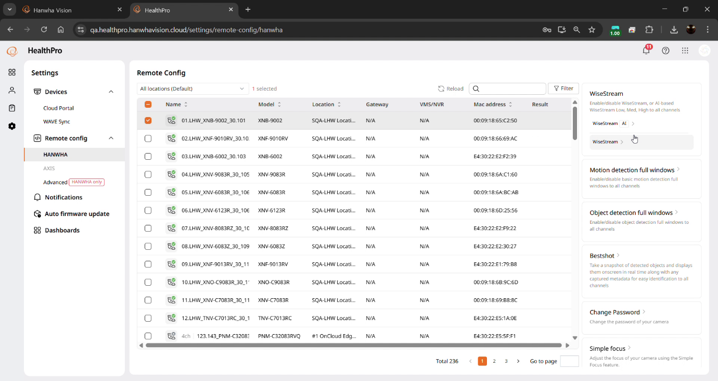

* Advanced mode: Send SUNAPI commands via the public Internet, to multiple HealthPro Bridge and D2C cameras. For the full list of commands in the SUNAPI documentation, please contact your sales representative.

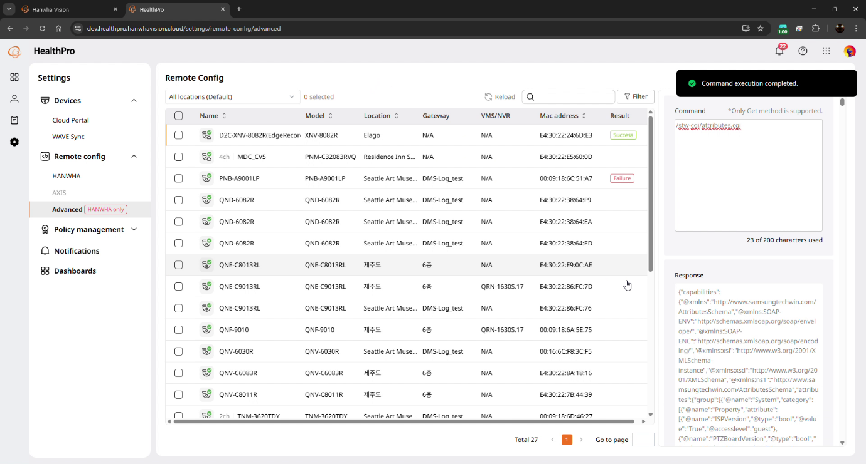

**Notification Center**

* In general, the Notification Center has been revamped to gives users greater control of what they wish to be notified about, and how, as well as being able to manage tasks in bulk.

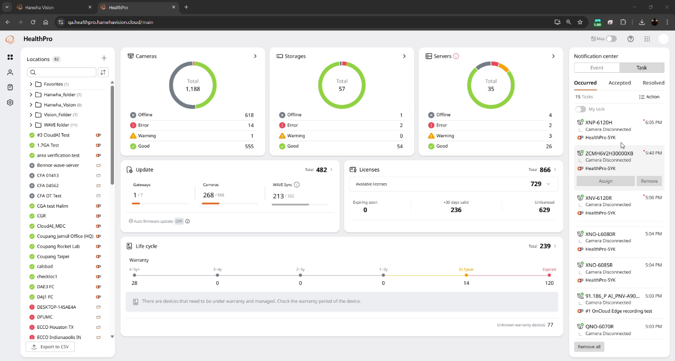

* At the Organization level, enable or disable the creation of tasks. When created, tasks appear in the Notification Center.

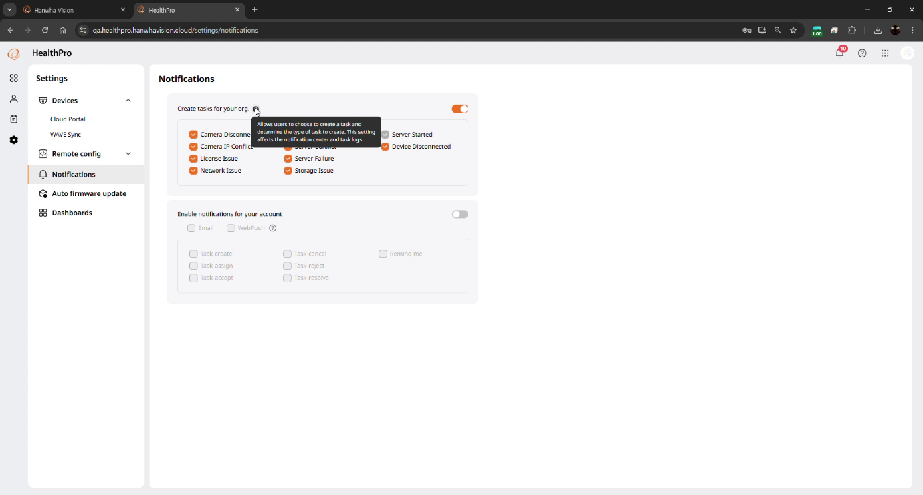

* At the individual account level, choose which task-related events to be notified of, including created, assigned, accepted, cancelled, rejected, and resolved tasks.

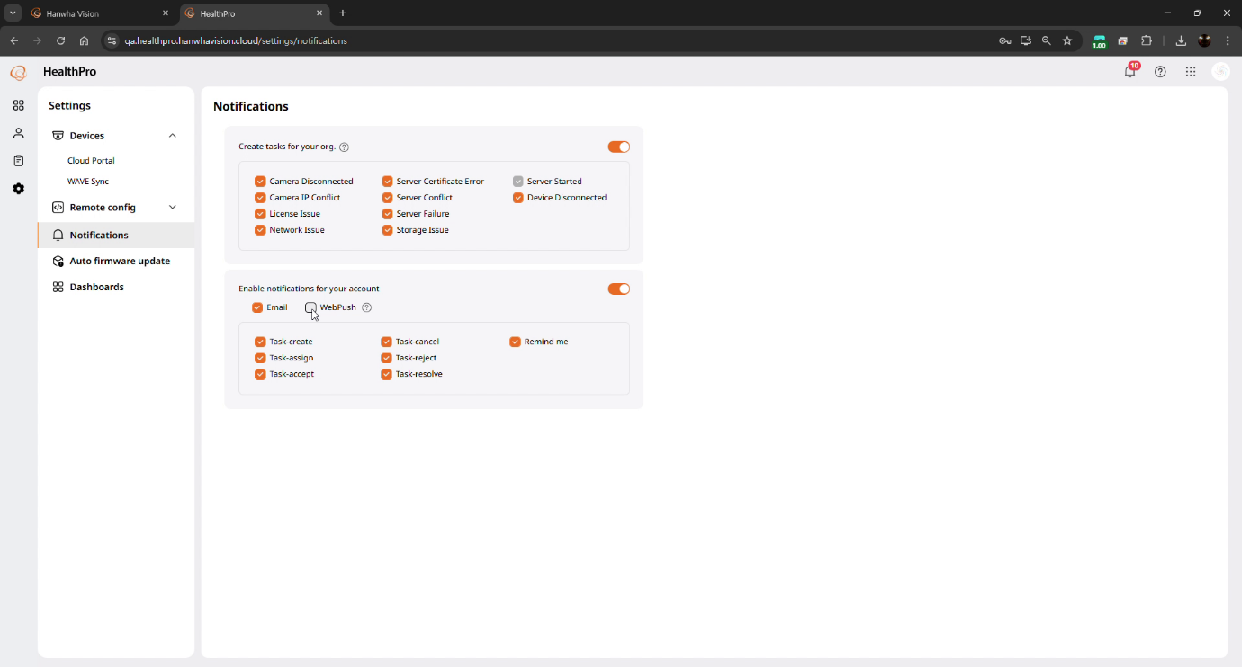

* Bulk Assign, Accept, and Resolve or Remove up to 100 tasks sitting in the Notification Center. This can be helpful when clearing out a backlog.

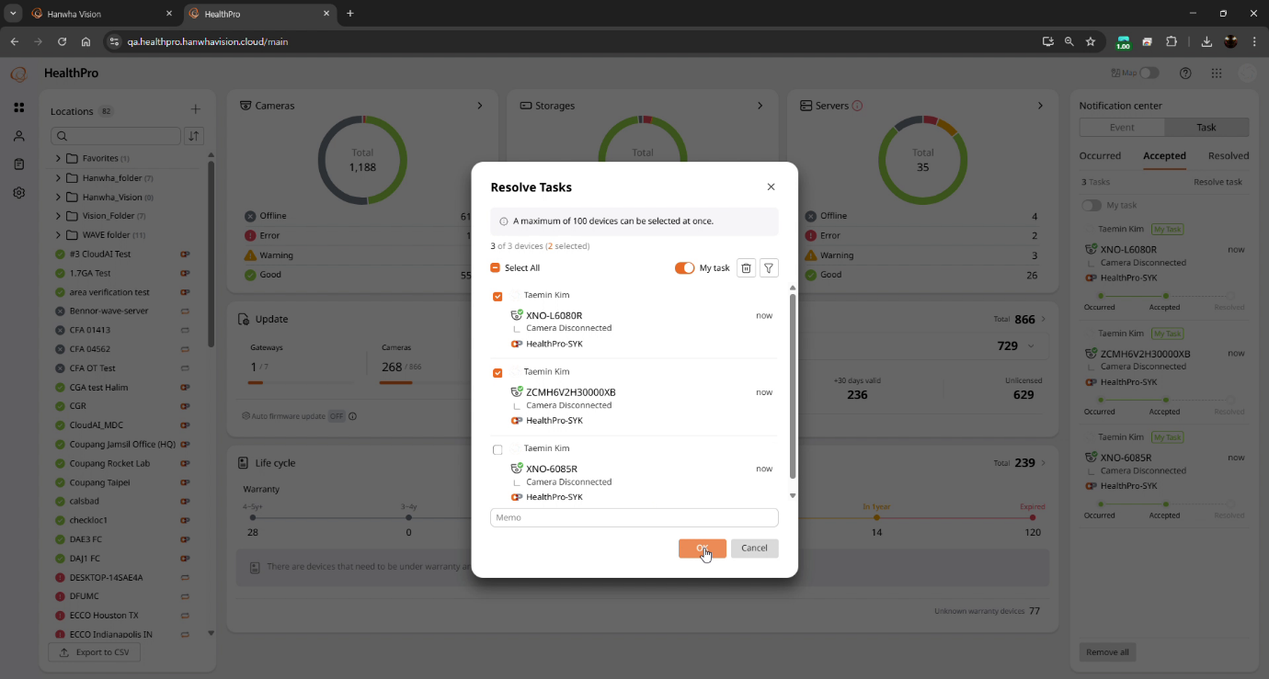

* Resolved tasks are hidden from the Notification Center after 24 hours, but will remain in the task logs.

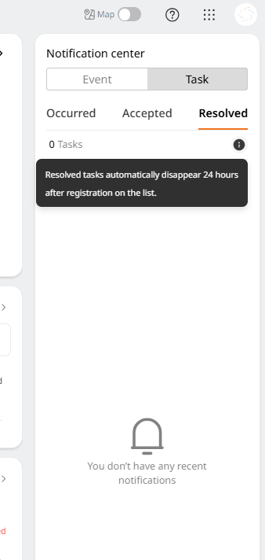

**Exporting**

* In general, HealthPro is uniquely positioned to consolidate a mass of camera and system data across the system. Such information includes camera models, IP, serial numbers, and MAC addresses, year of manufacture, remaining warranty, current firmware version, physical location, and more. This information may be exported for further analysis, or imported to an Asset Management system. This release further strengthens this ability.

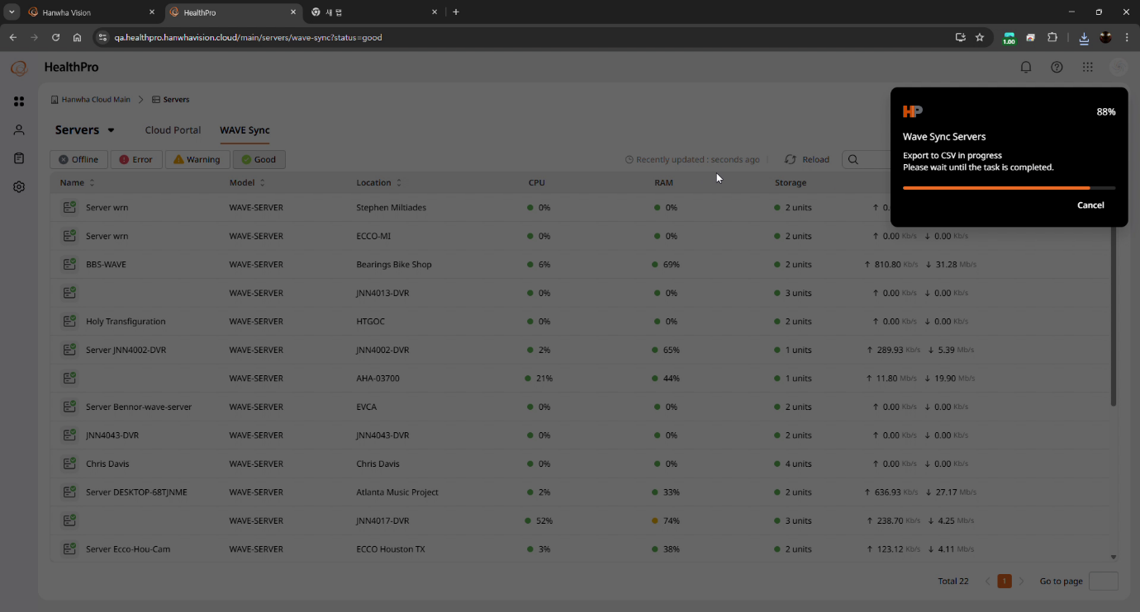

* Bulk CSV export all the information registered in the Settings menu, including all users.

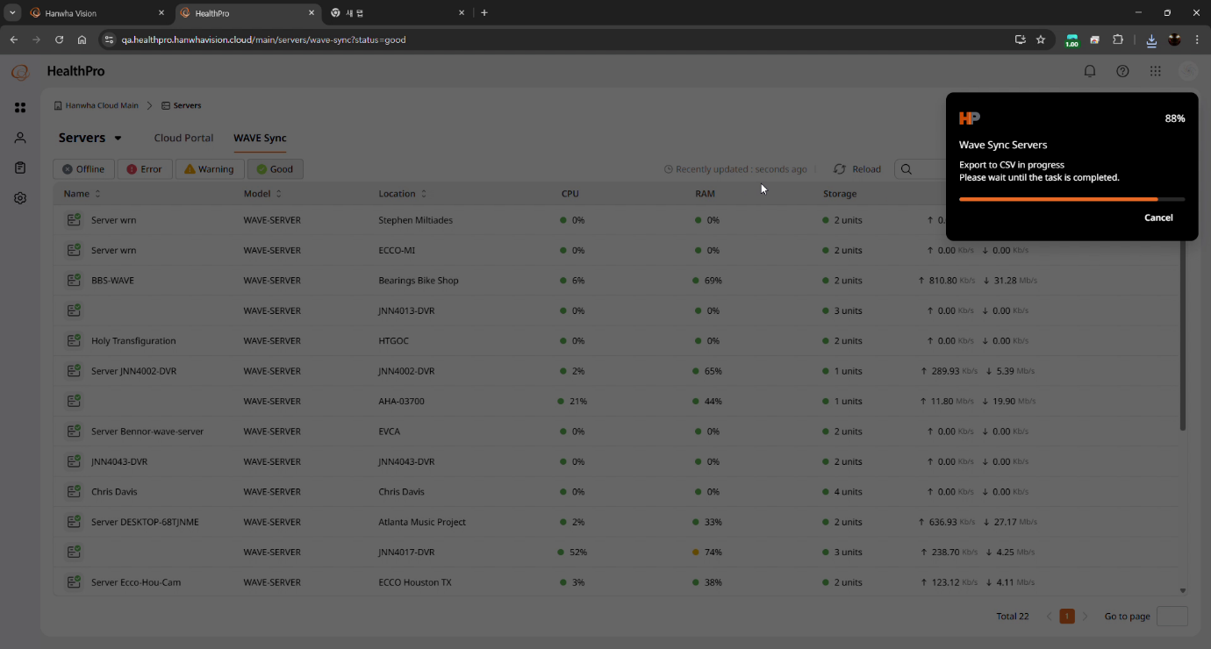

* Bulk CSV export unlimited User log entries.

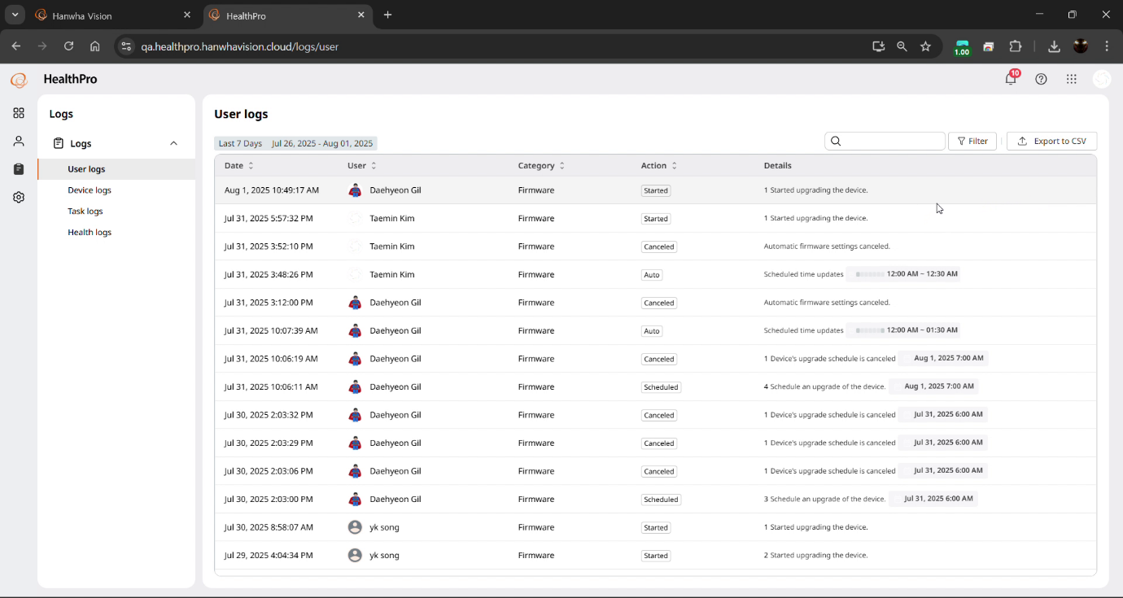

* Bulk CSV export up to the 10,000 most recent entries in the Device, Task, and Health logs. HealthPro preserves the trailing 90 days of these logs. Since they can be very large files it is recommended to apply filters to focus on the relevant log entries.

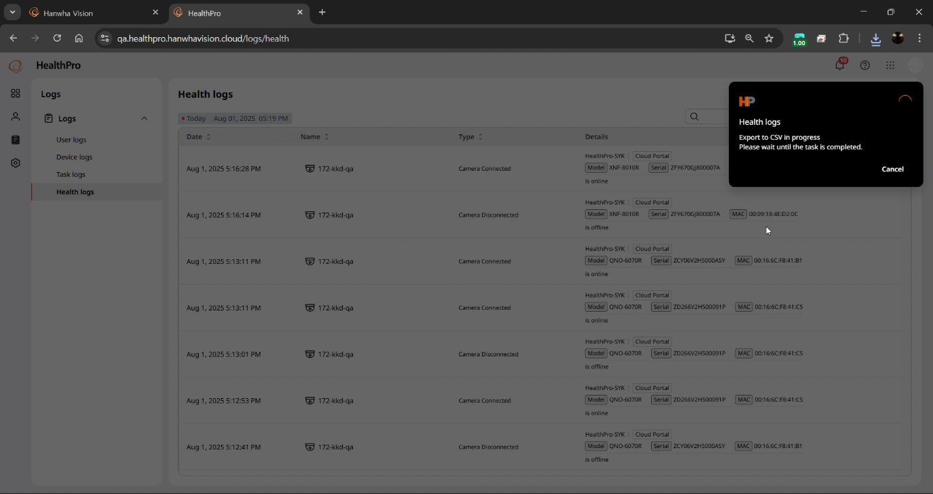

* Bulk CSV export a list of all Locations for the Organization.

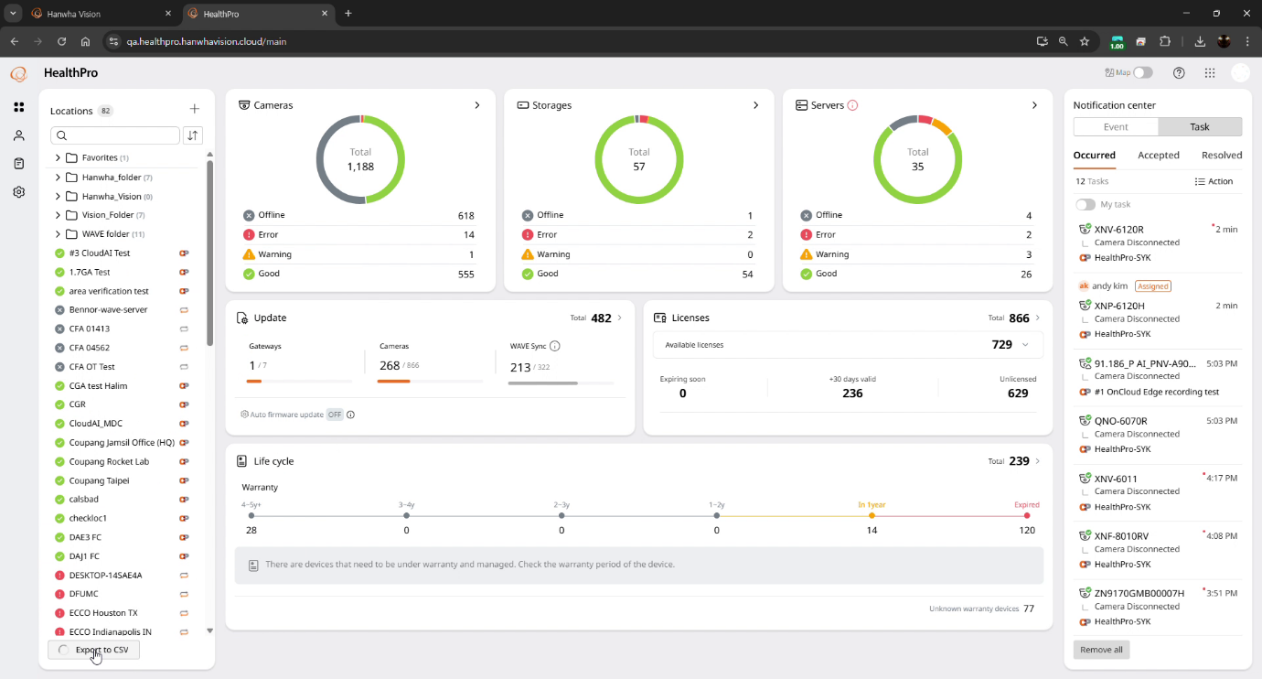

* Download camera log files. This includes both Hanwha Vision and AXIS devices, and Access, System, and Event logs.

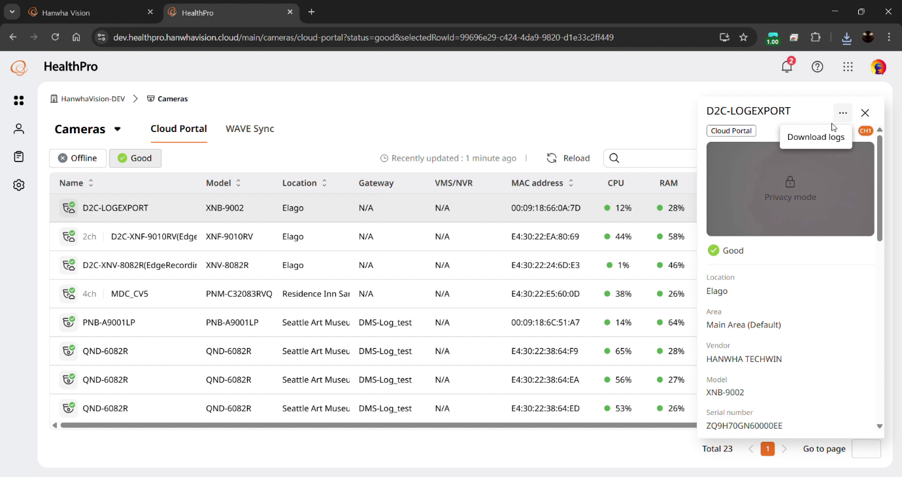

* Camera dashboard exported files include SD/SSD storage details for licensed cameras.

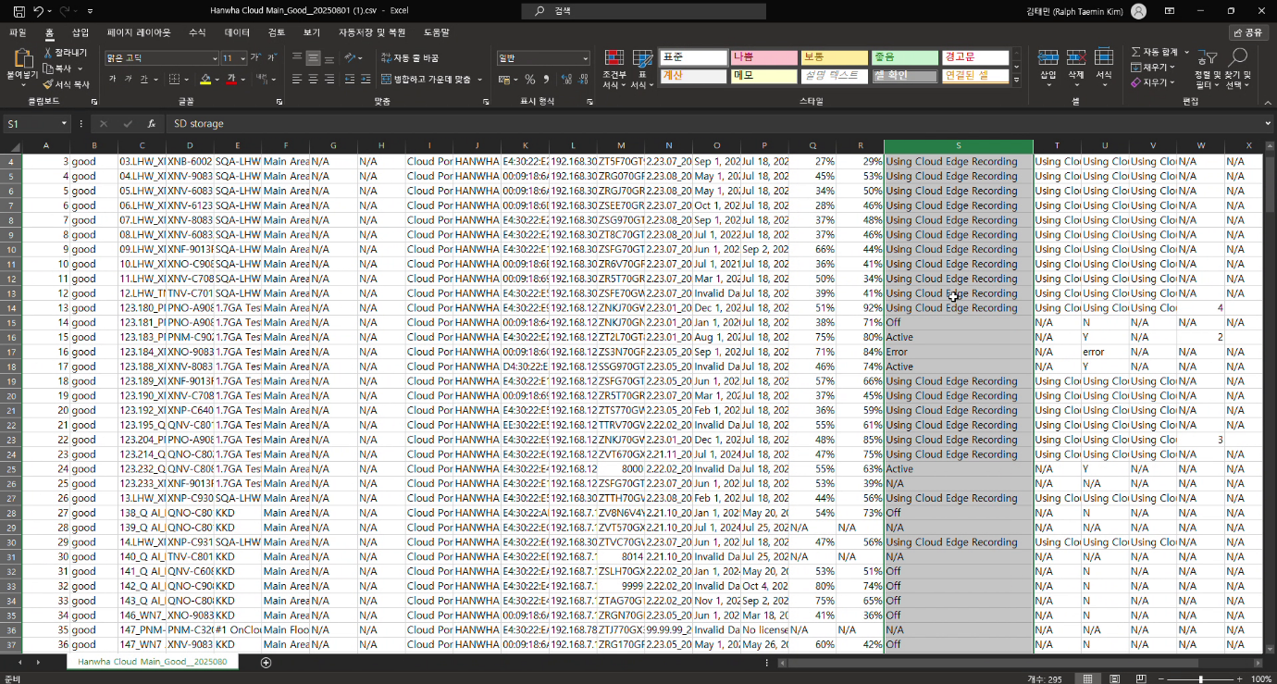

**NVRs and WAVE**

* Monitor Hanwha Vision XRN/QRN/PRN/ARN-series NVR cameras and the NVR’s storage

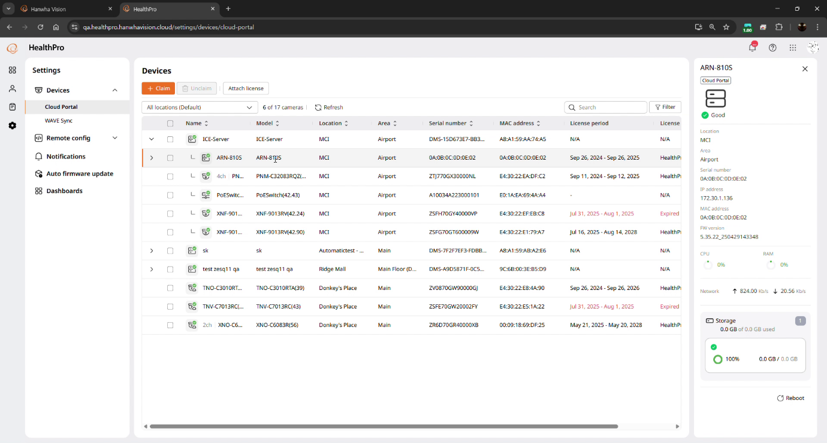

* Monitor WAVE storage information via HealthPro Bridge (this was previously only possible via WAVE Sync).

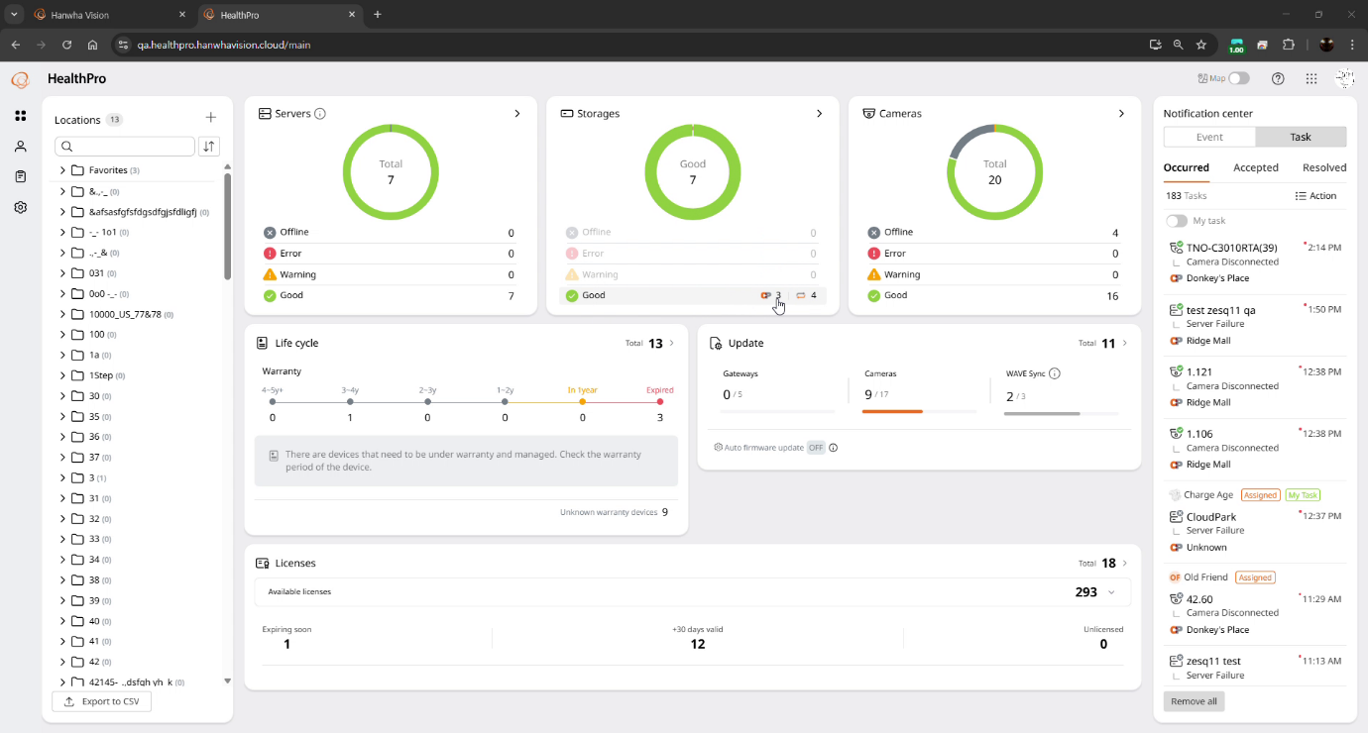

* Receive notifications if the attached WAVE Sync account’s password has changed or if the token has expired and the credentials need to be re-entered.

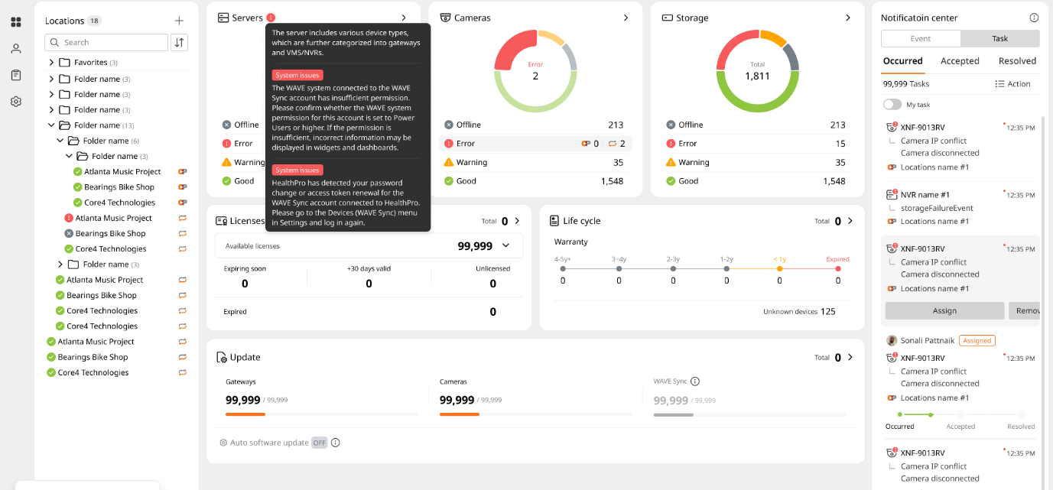

* WAVE Sync accounts will not be attachable to HealthPro unless the WAVE Sync account has Power User or higher permissions. This is to avoid the confusion from accounts being attached but information not flowing due to inadequate permissions..

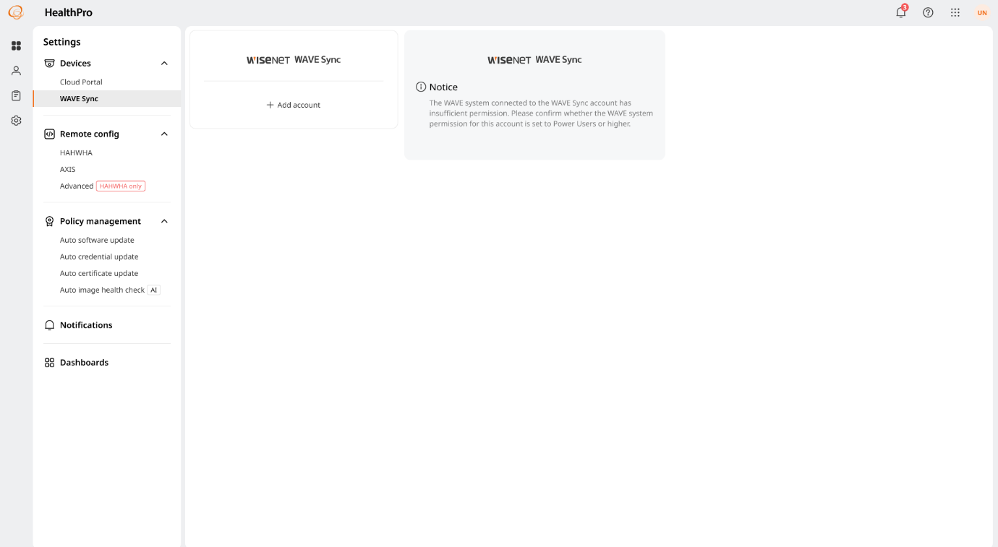

**Network Switch PoE Port Power Cycling**

* HealthPro can power cycle the PoE port on managed switches for licensed cameras, for when a camera needs a hard power cycle (not merely a soft reboot).

