What’s new in v1.7.2

*\*Note: If there is a difference between the content of this document and other KB articles, please give priority to the content of this document.*

* HealthPro displays WiseAI features in the camera dashboard and camera details. (BETA)

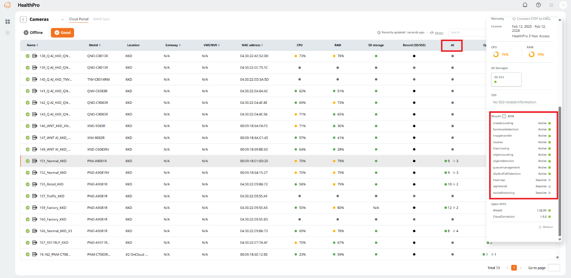

* Bug fixes.