What’s new in v1.7 (HealthPro Bridge)

*\*Note: If there is a difference between the content of this document and other KB articles, please give priority to the content of this document.*

* HealthPro Bridge users can scan and add up to 800 child devices to Cloud Portal.

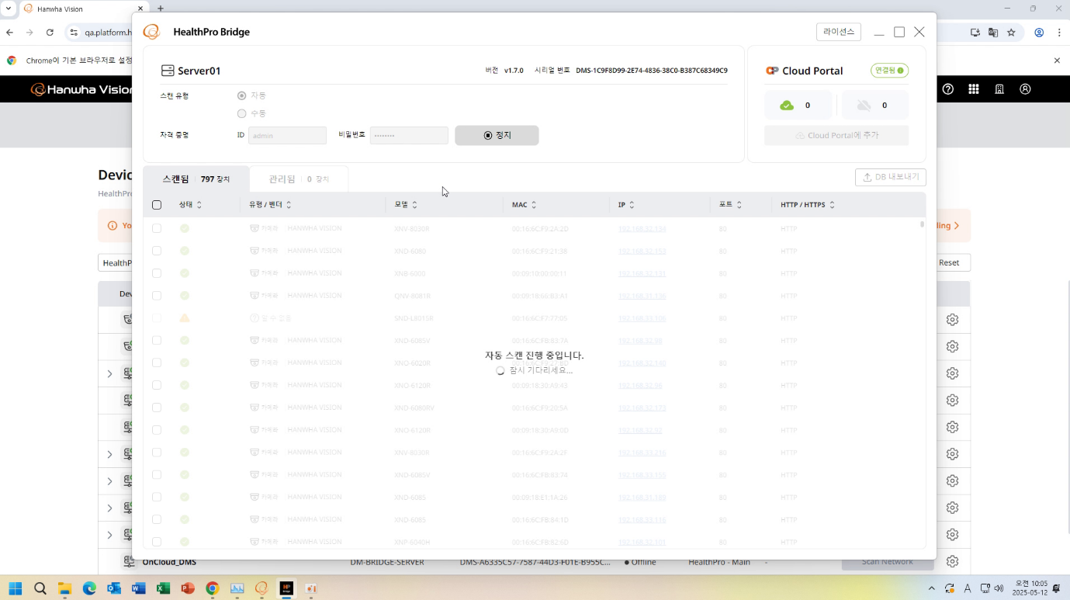

* When HealthPro Bridge scans for sub-devices it will exclude localhost 127.0.0.1 from the search results.

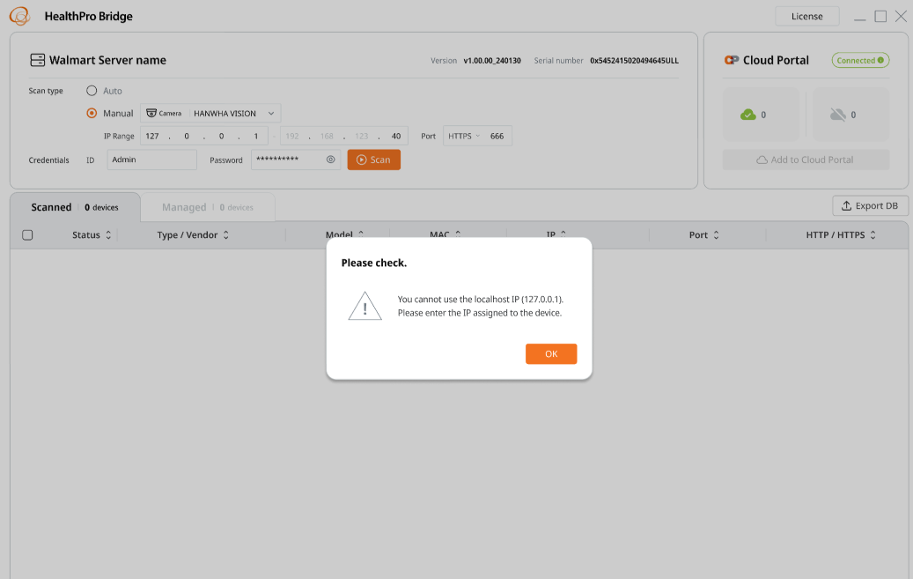

* The CPU and RAM usage of Hanwha Vision cameras is displayed in HealthPro.

(Refer to What is new v1.7_HealthPro)

* Firmware updates can use zipped firmware files regardless of their internal structure.

If the firmware in the zip file includes bridge firmware, you can update the camera normally by going through two update processes (install the bridge firmware included in the zip file first, then install the latest firmware).

*bridge firmware: This is not related to the HealthPro Bridge and is the name of the firmware that must be installed first when there is a major change to the camera.

* HealthPro users can normally update the firmware of derivative models (Korean Government TTA certified models) registered on the HV homepage.

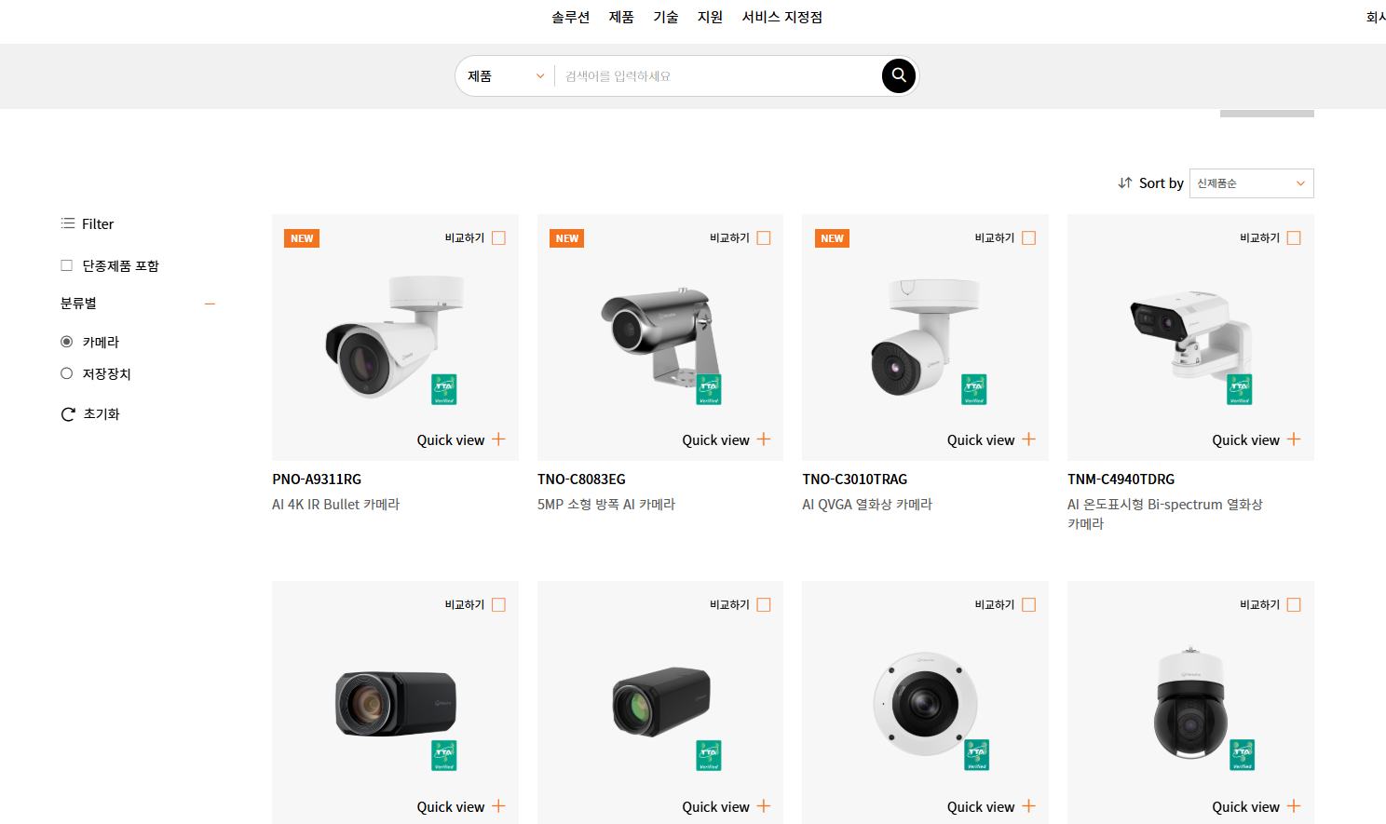

* The health log now includes WAVE servers and their cameras, extending coverage beyond HealthPro Bridge servers and its cameras.

(Refer to What is new v1.7_HealthPro)

* Multi-language support: HealthPro supports English, French, German, Spanish, Portuguese, Italian, and Korean.

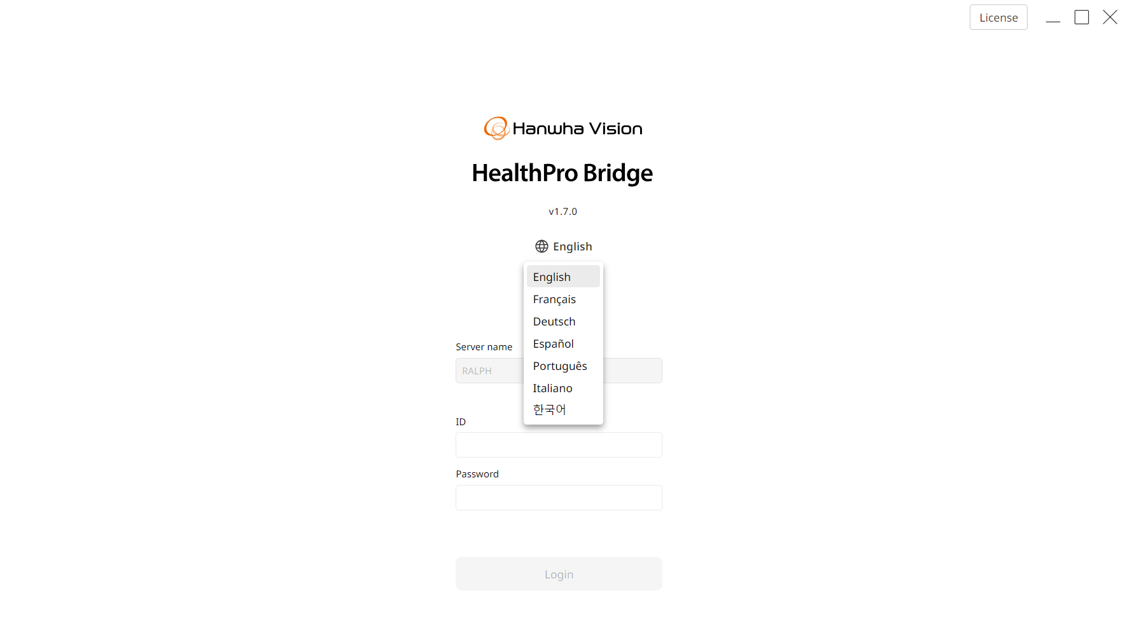

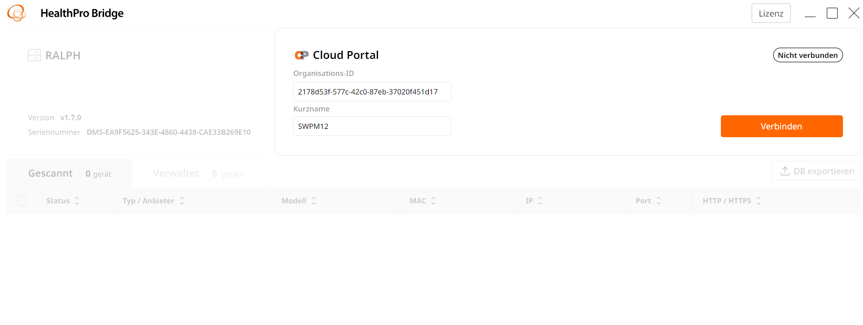

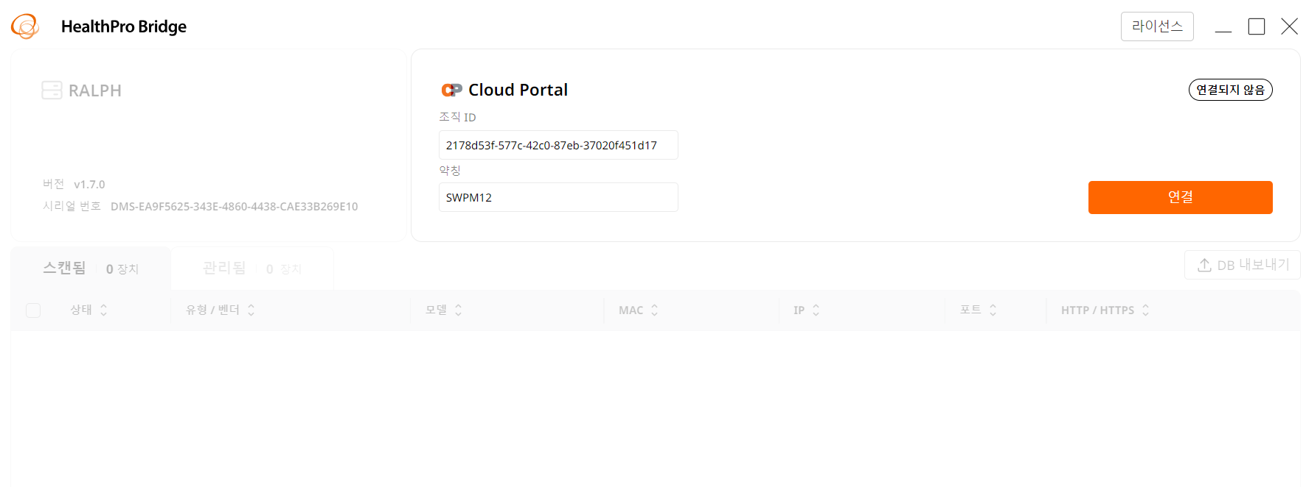

* Bug fixes.