What’s new in v1.7

*\*Note: If there is a difference between the content of this document and other KB articles, please give priority to the content of this document.*

* HealthPro scales up to 5,000 locations.

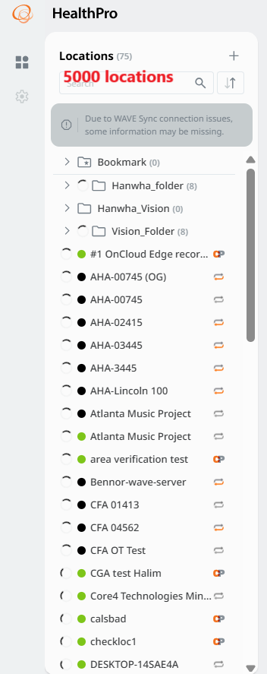

* Instantly filter search results for devices for scalability.

If there are two servers with the same name in the camera dashboard (Server 1 (id: 1), Server 1 (id: 2), only Server 1 will be displayed in the filter list, and when the filter is selected, all devices with the server name (Name) of Server 1 will be displayed.

* Instant tree view of folders and locations so that users can quickly browse without having to pull up a location's dashboard, and then have to reverse back out.

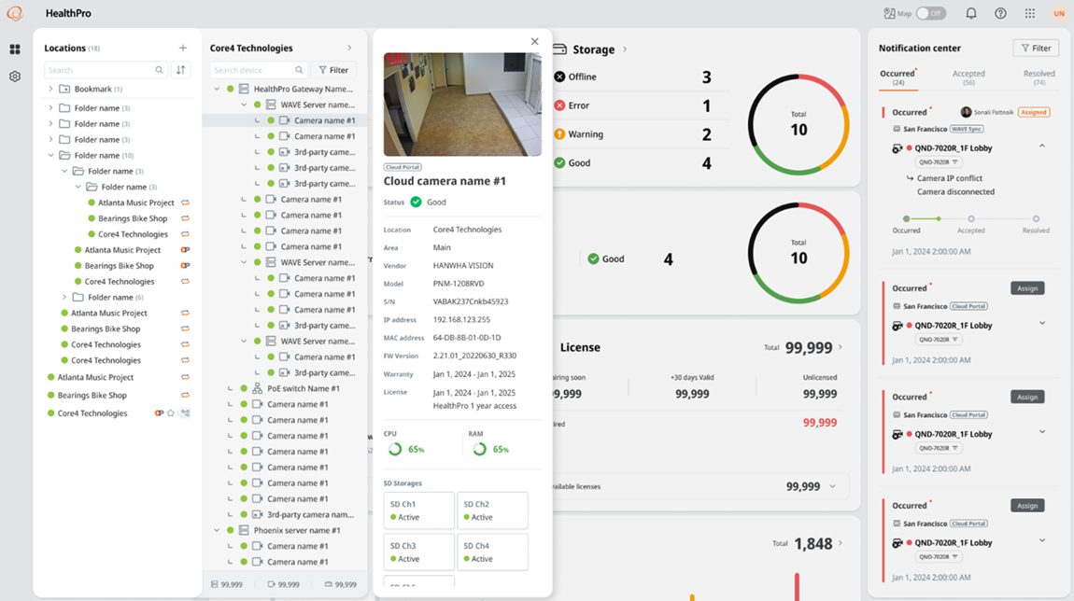

* Large locations (100+ devices) will have their dashboards split for pagination, for scalability.

Dashboard pagination

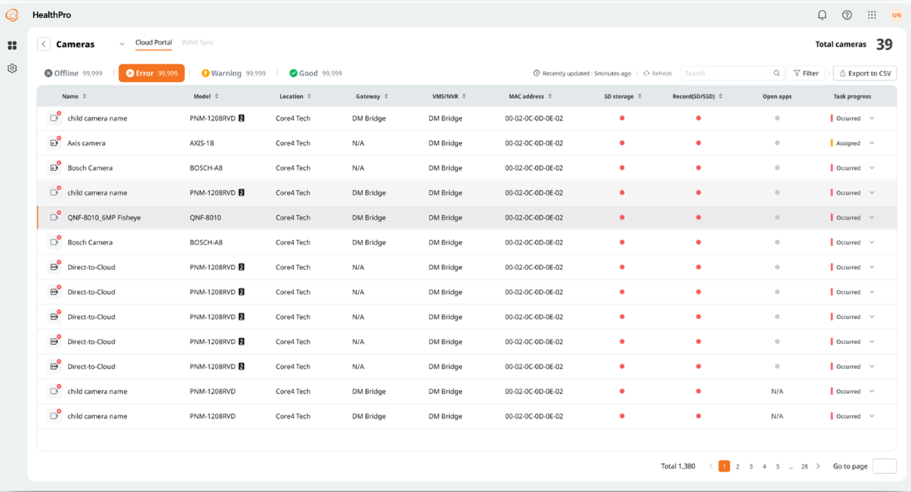

* For large systems, users can keep loading 100 more devices when viewing device details for scalability.

Devices (list) load-more

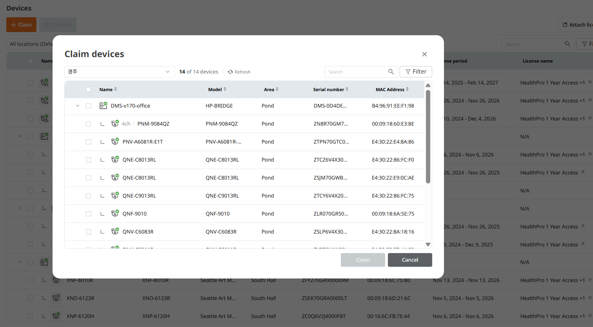

* For large systems, device details are paginated in batches of 100 for scalability.

Dashboard pagination

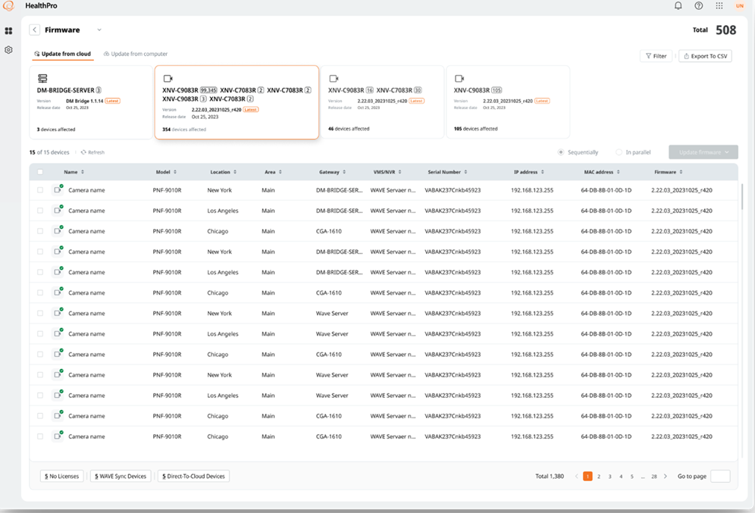

* During license attachment, a progress bar indicates that the process is active.

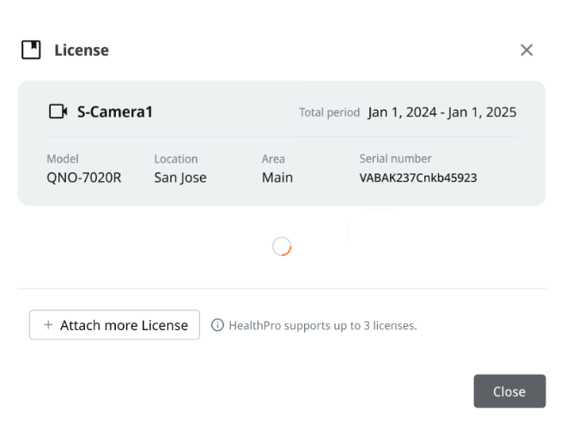

* Health logs now include Direct-to-Cloud as well as HealthPro Bridge devices.

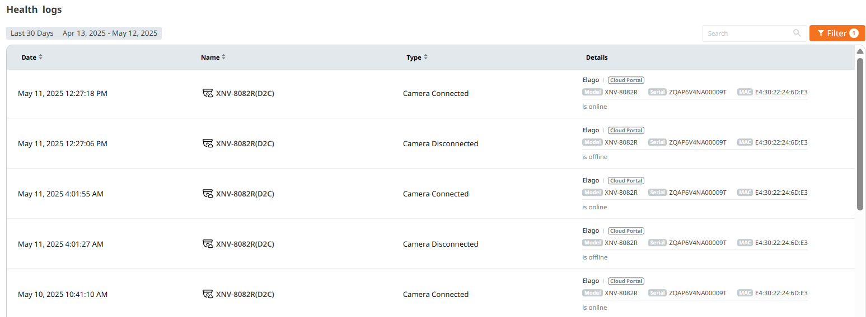

* Health logs now include WAVE servers and cameras connected via HealthPro Bridge.

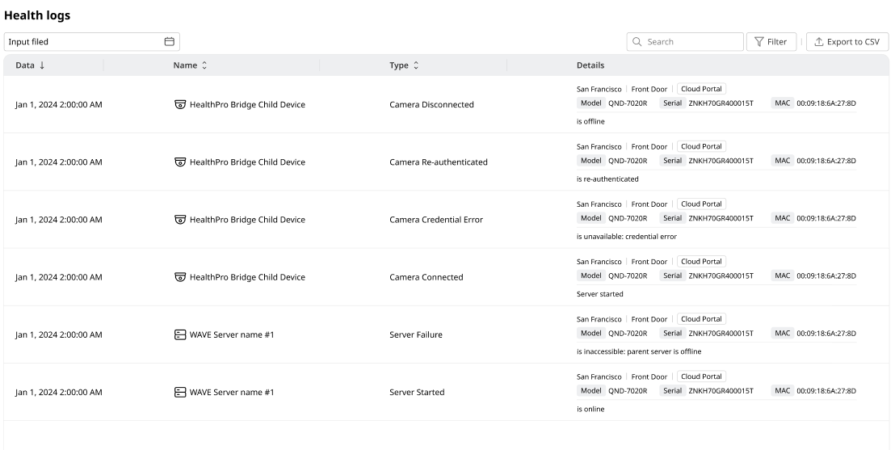

* For privacy, camera thumbnails can be omitted or blurred by the HealthPro Super manager.

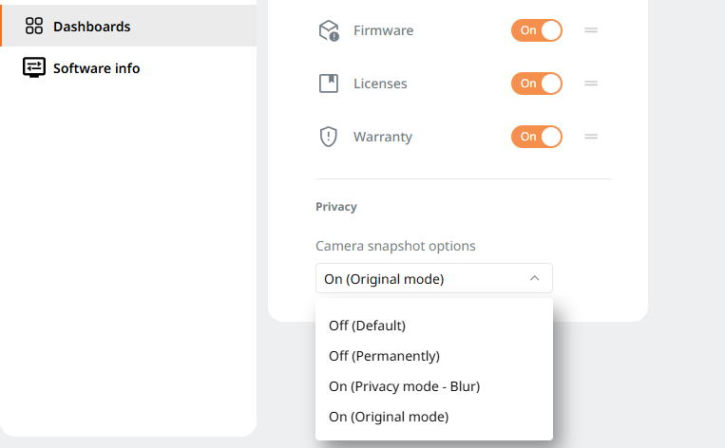

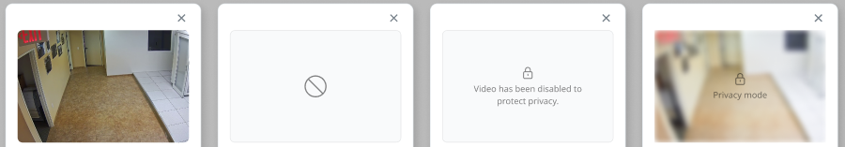

* Users can review the CPU and memory utilization of both Direct-to-Cloud as well as HealthPro Bridge devices.

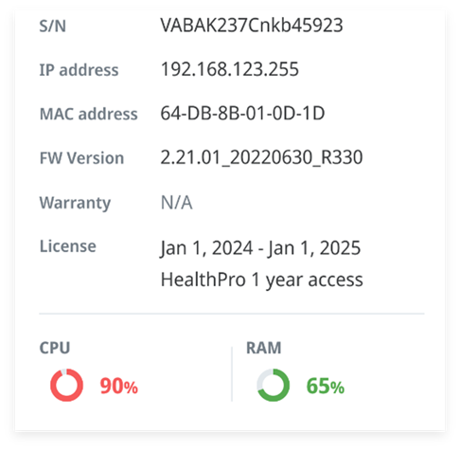

* To get a truer picture of how up to date devices are, excluded devices for automatic firmware updates now includes all HealthPro-claimed devices, regardless of their licensing status.

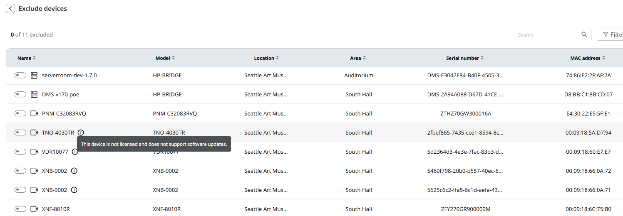

* Users may immediately switch to the E-map view, without having to wait for the entire dashboard to load.

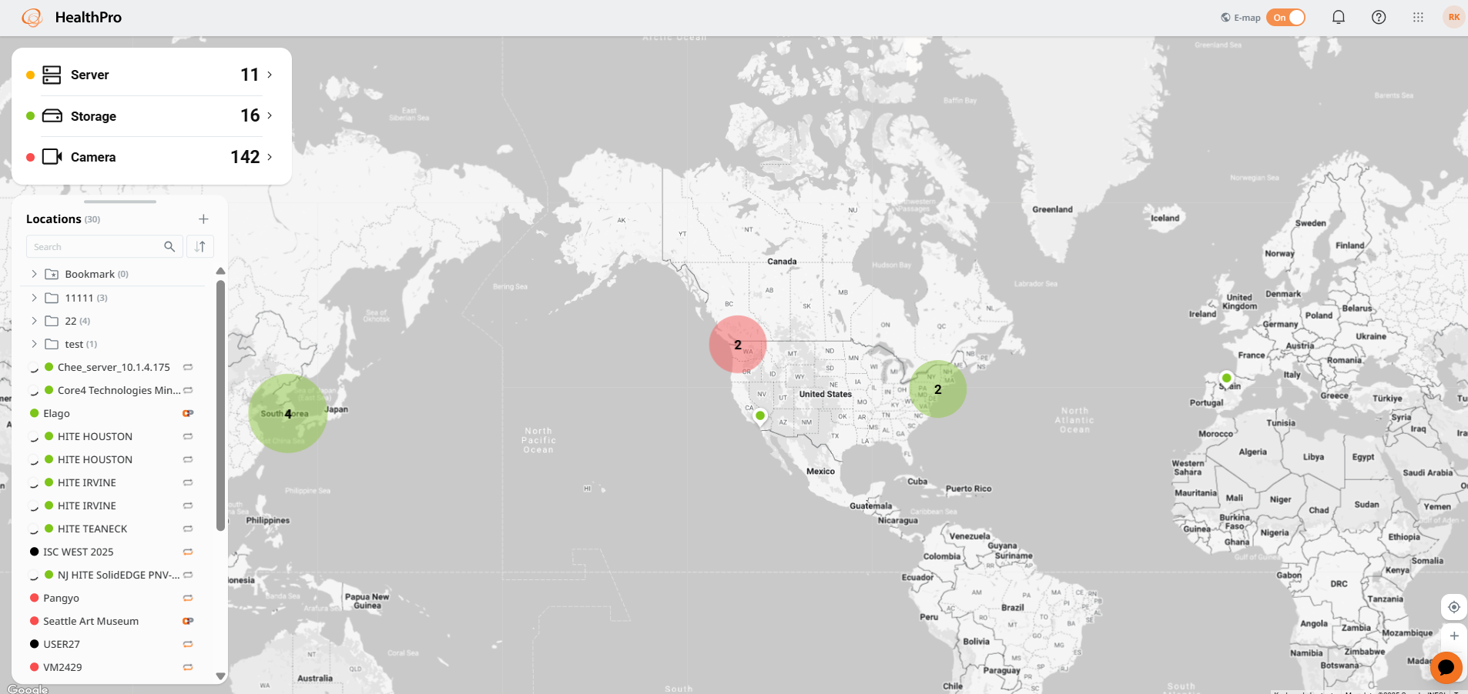

* Users can close device details by clicking anywhere else on the screen.

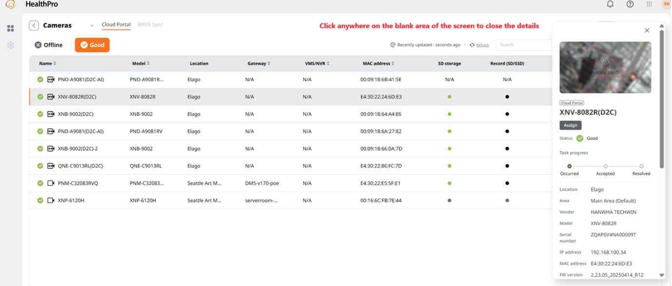

* Users have continuous access to the help chatbot (ADA) to answer any questions.

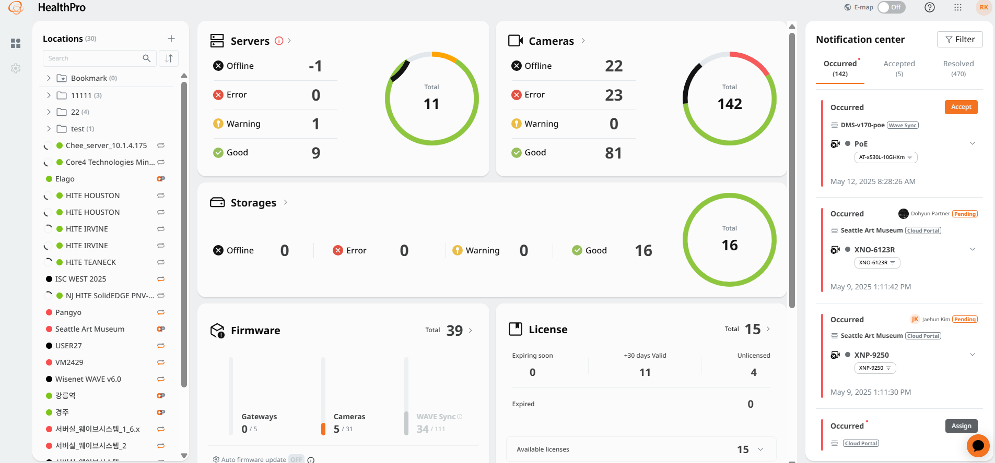

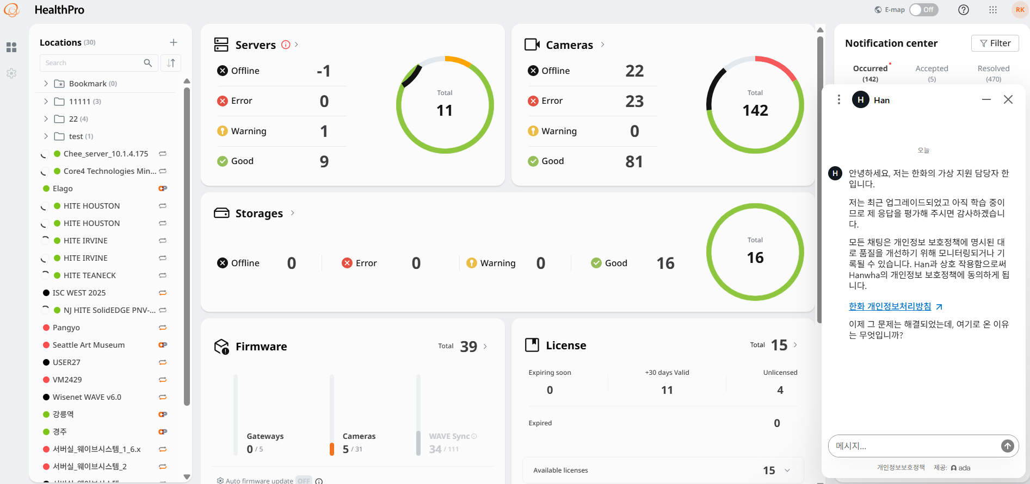

* Users can see whether the organization is enrolled in the Client Retention Program, and can check their special warranty terms. Note the customer must ensure their special STEP Code is added to their org via Cloud Portal before onboarding cameras to ensure the correct warranty period is applied.

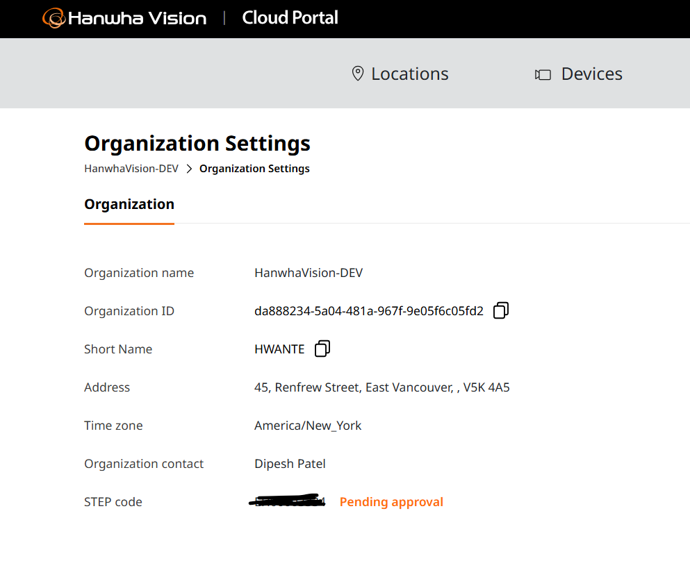

* The warranty dashboard has been expanded and redesigned into a life cycle dashboard, providing comprehensive life cycle information, including warranty information.

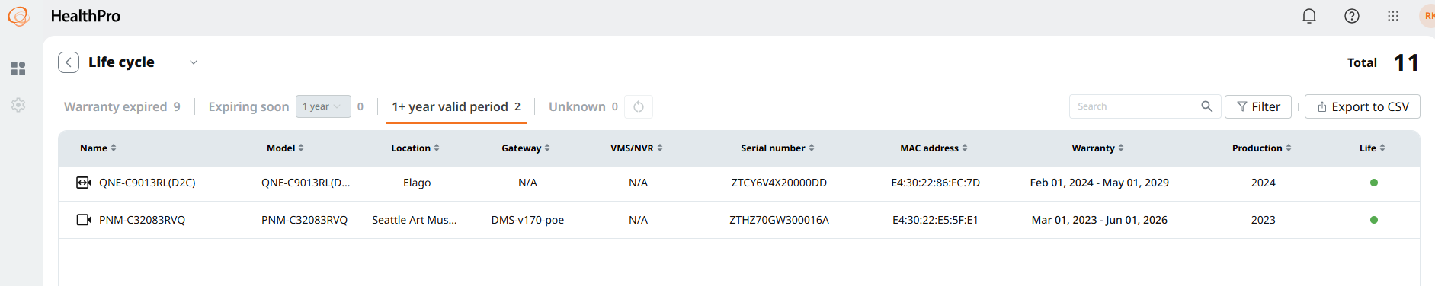

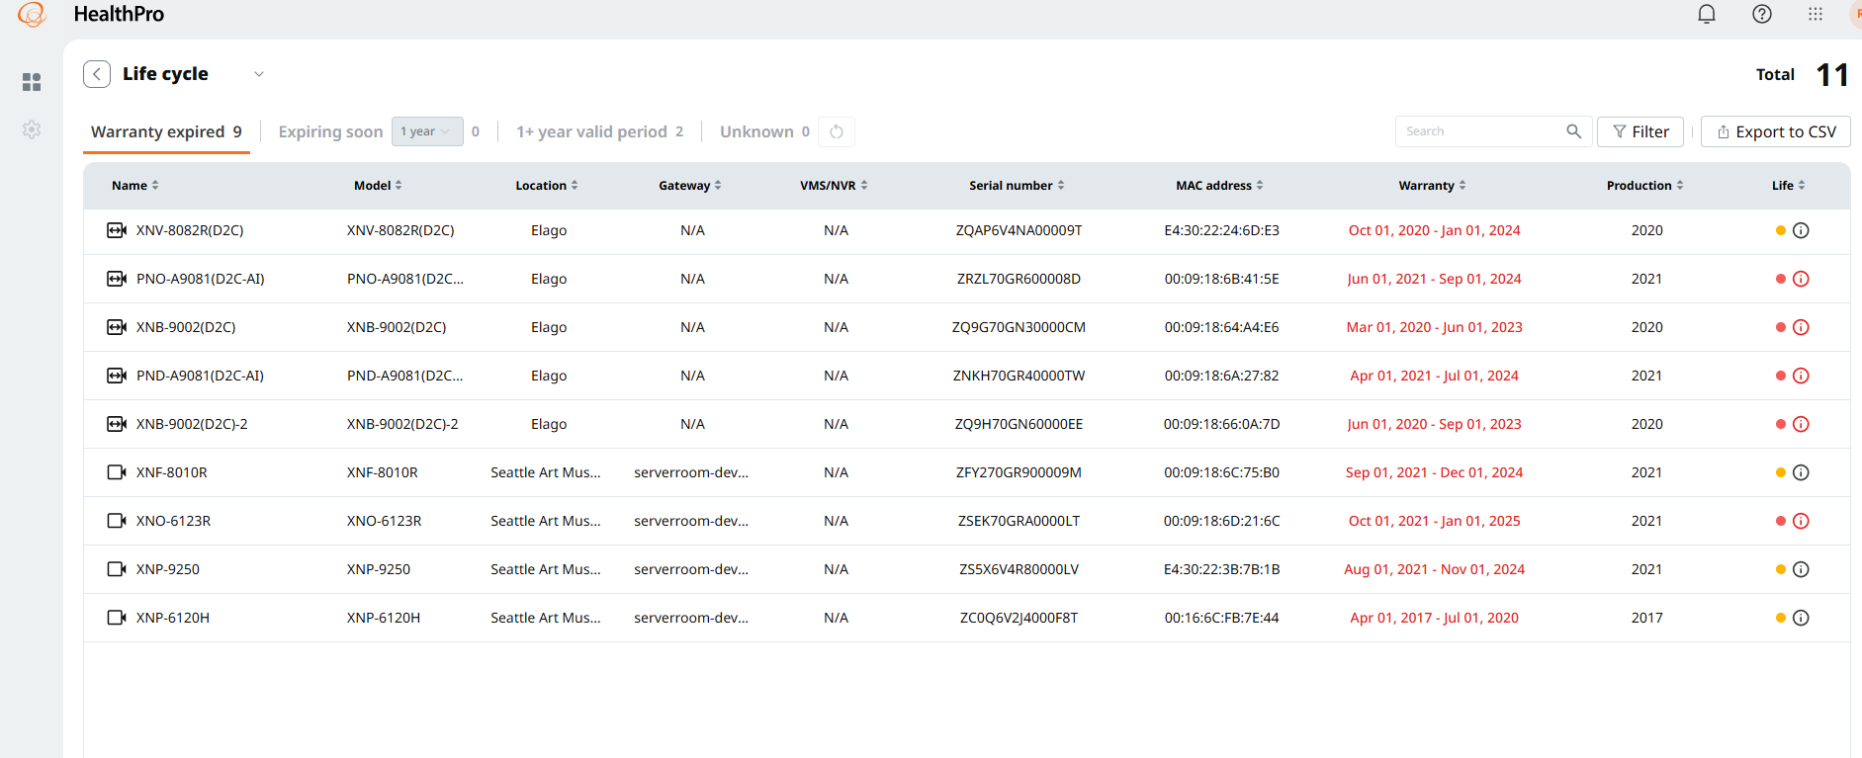

* The server widget includes an explanatory icon and text.

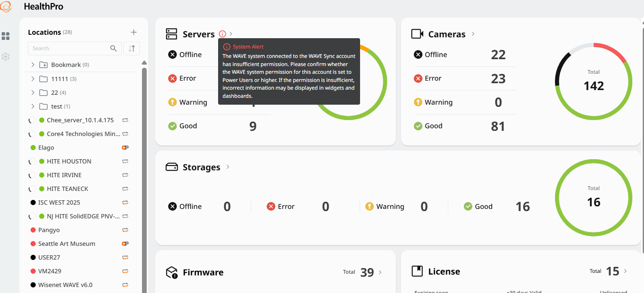

* Constantly visible help icon with links to Training and Contact Us.

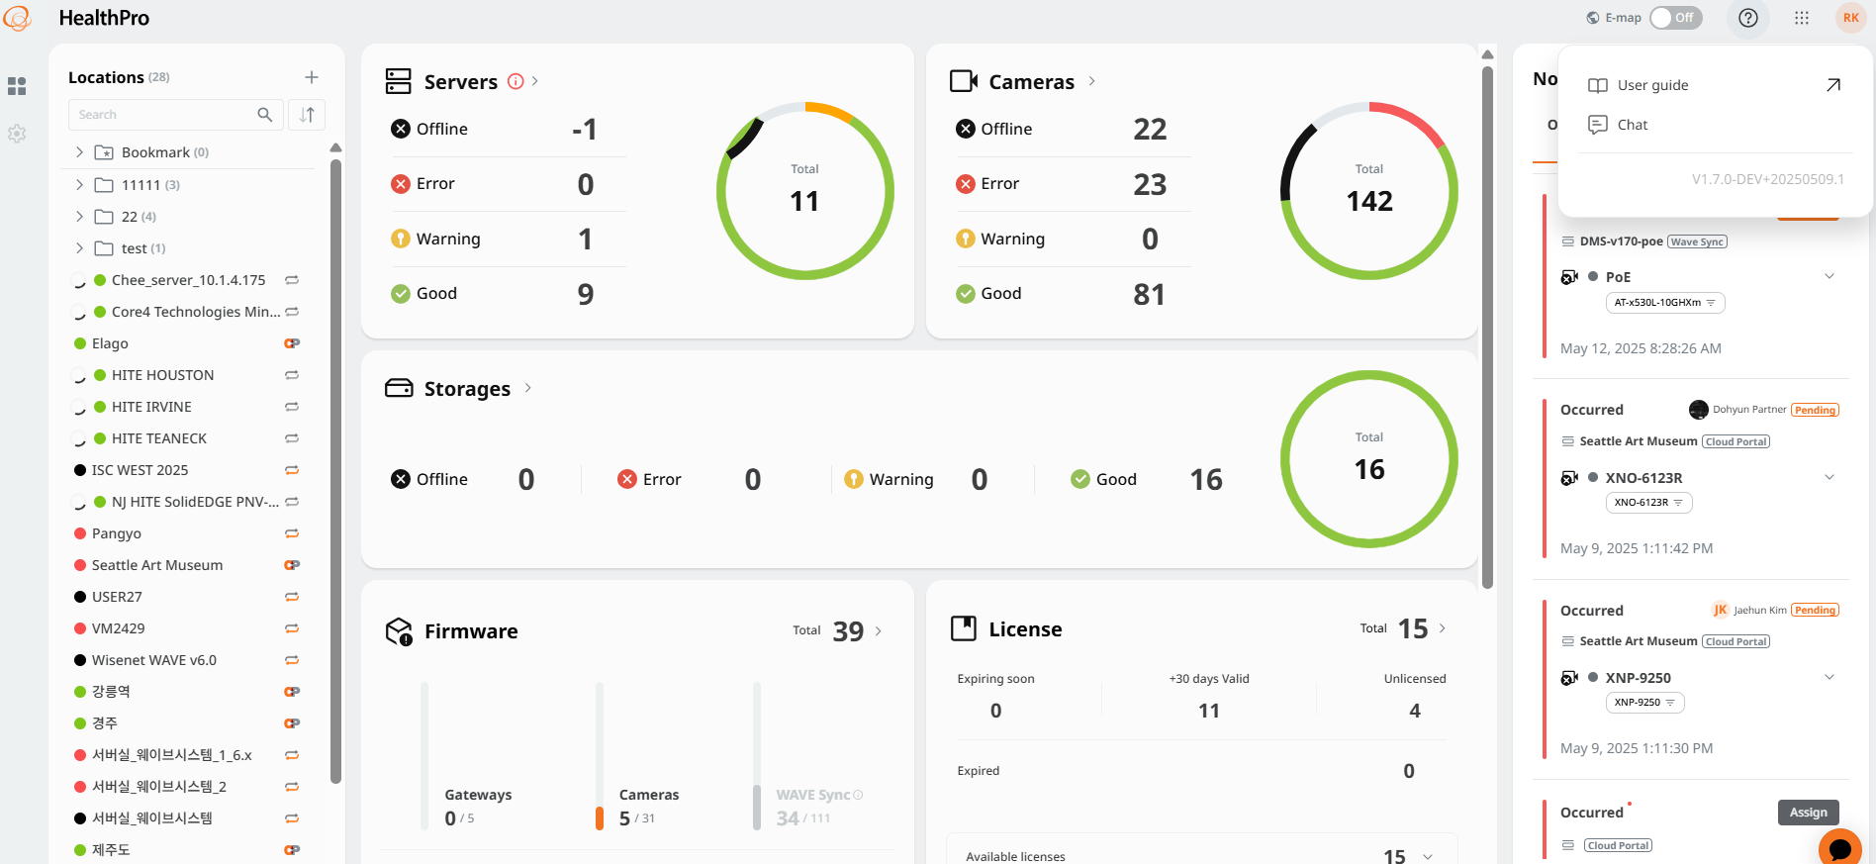

* The beta Linux HealthPro Bridge is excluded from the firmware dashboard. To update it install the update manually on-demand.

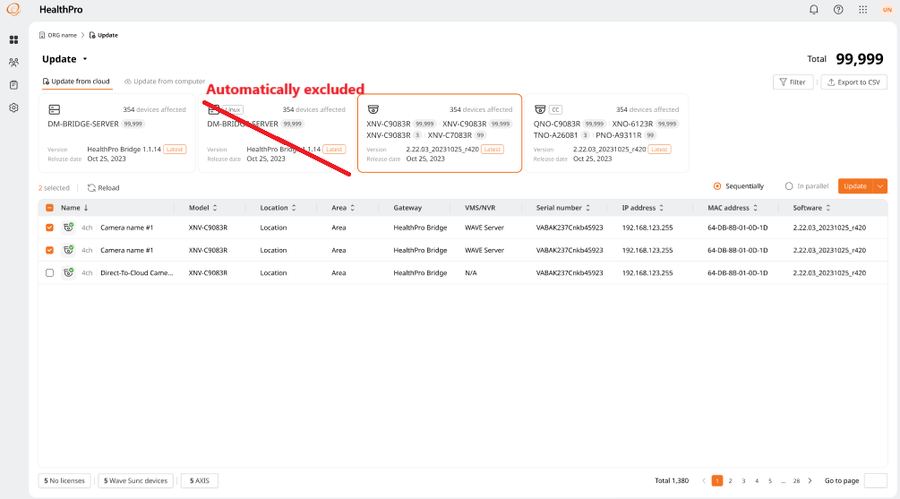

* Multi-language support. HealthPro supports English, French, German, Spanish, Portuguese, Italian, and Korean.

This is a beta version and language settings are only possible via the Cloud Portal user profile when supporting multiple languages ​​in the Cloud Portal.

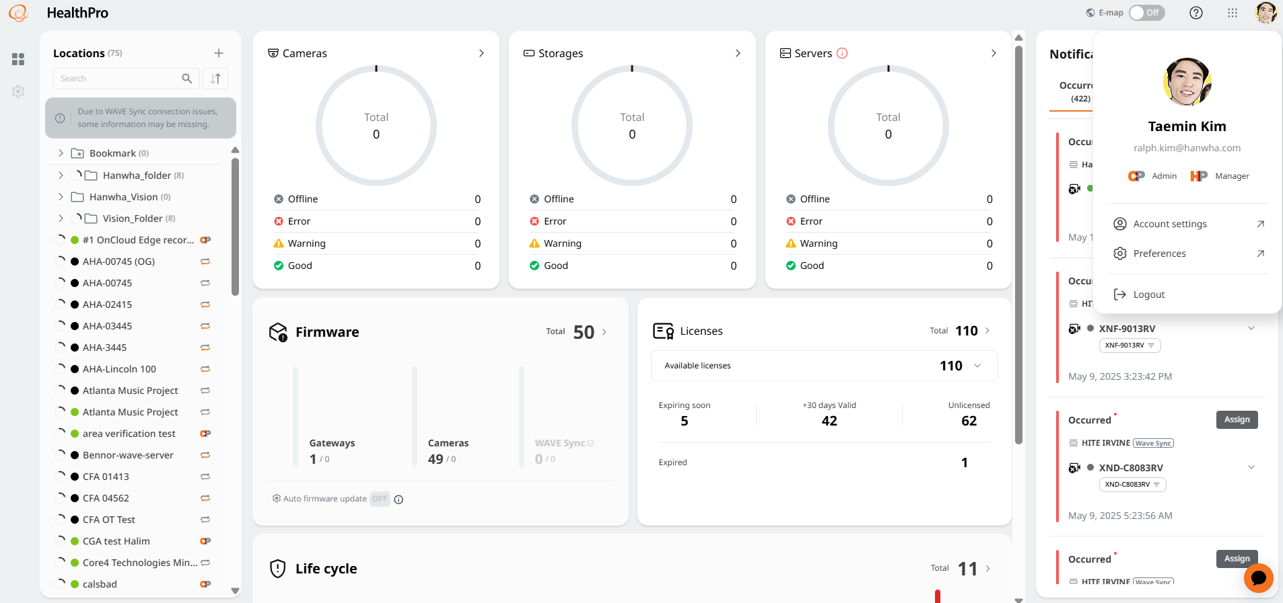

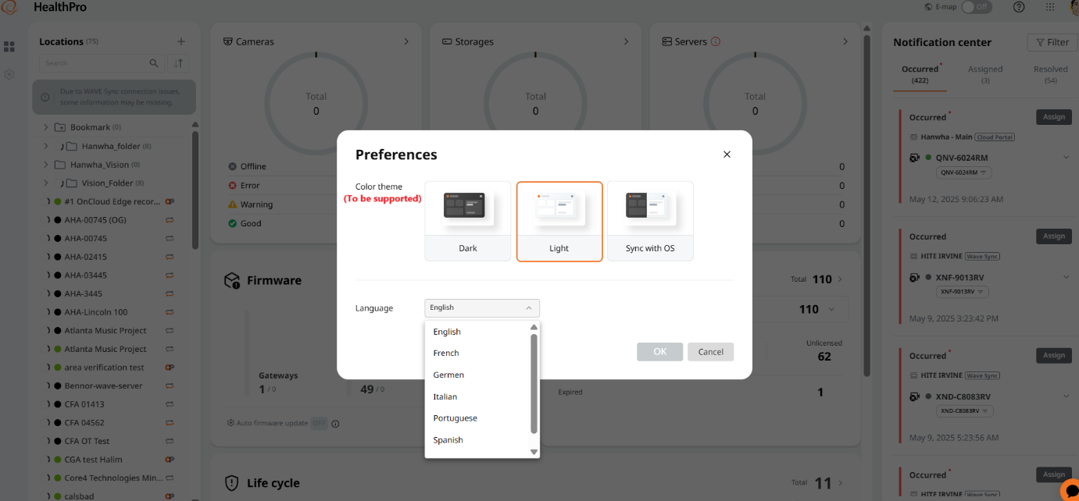

* Users are notified immediately of any WAVE sync permission issues.

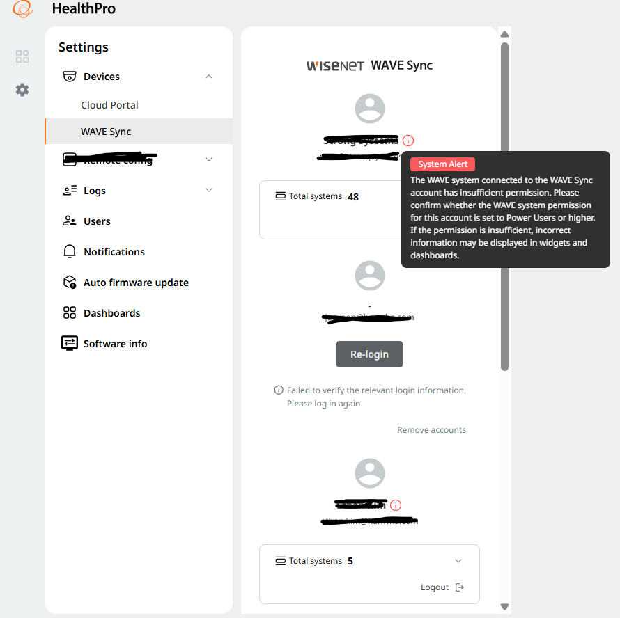

* An issue with the task log status name has been fixed.

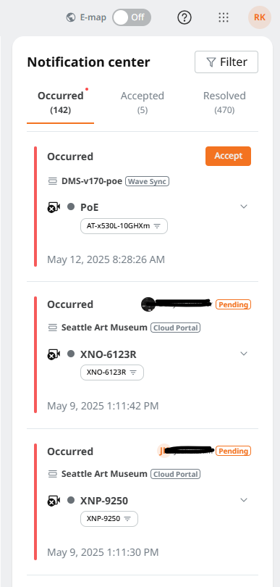

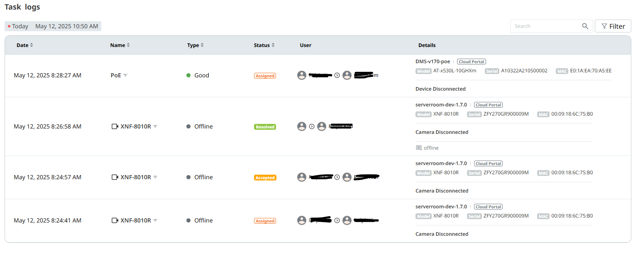

* Bug fixes.